HELPDESK PRO – IT SUPPORT TICKET SYSTEM
A PROJECT REPORT
Submitted by
ELANGO G
(2116241501055)
in partial fulfilment of the End Semester Examination for the course
CB23F35 –
LOW-CODE APPLICATION DEVELOPMENT USING ZOHO CREATOR
in
BACHELOR OF TECHNOLOGY
ARTIFICIAL INTELLIGENCE AND MACHINE LEARNING

RAJALAKSHMI ENGINEERING COLLEGE
(An Autonomous Institution, Affiliated to Anna University, Chennai)
Rajalakshmi Nagar, Thandalam, Tamil Nadu – 602 105
OCTOBER 2026
RAJALAKSHMI ENGINEERING COLLEGE
(An Autonomous Institution, Affiliated to Anna University, Chennai)
BONAFIDE CERTIFICATE
Certified that this project report titled “HELPDESK PRO – IT SUPPORT TICKET SYSTEM” is the bonafide work of ELANGO G (2116241501055), who carried out the individual project work on the Zoho Creator low-code platform for the course CB23F35 – Low-Code Application Development using Zoho Creator, during the academic year 2026–2027, Semester V, under my supervision.
SIGNATURE  Dr. M. Ayyadurai, M.E., Ph.D.,  HEAD OF THE DEPARTMENT  Department of Artificial Intelligence and Machine Learning  Rajalakshmi Engineering College  Thandalam – 602 105 | SIGNATURE  Priya M, M.E  COURSE FACULTY  Assistant Professor  Department of Artificial Intelligence and Machine Learning  Rajalakshmi Engineering College

Submitted for the End Semester Examination (Individual Project) held on
INTERNAL EXAMINER | EXTERNAL EXAMINER

DECLARATION
I, ELANGO G (2116241501055), hereby declare that the project report titled “HELPDESK PRO – IT SUPPORT TICKET SYSTEM”, submitted for the End Semester Examination of the course CB23F35 – Low-Code Application Development using Zoho Creator, is a record of original work carried out by me individually. The Zoho Creator application described in this report — including its data model, forms, reports, pages, Deluge scripts, workflows and integrations — was designed and developed by me.
I further declare that this work has not been submitted, in part or in full, for the award of any other degree or course credit. Every template, sample application, AI-assisted feature (such as Zia or the AI application builder), code snippet or external resource used in this work has been duly acknowledged in the report.
Place: Chennai SIGNATURE OF THE STUDENT
Date: ELANGO G
2116241501055

ACKNOWLEDGEMENT
I express my sincere gratitude to our Chairman Mr. S. Meganathan, Chairperson Dr. (Mrs.) Thangam Meganathan and Vice-Chairman Mr. ABHAY SHANKAR MEGANATHAN, B.E., M.S., for providing the infrastructure and facilities that made this work possible.
I am grateful to our Principal, Dr. S.N. MURUGESAN, M.E., Ph.D., Rajalakshmi Engineering College, for the constant encouragement extended to students to take up industry-relevant learning.
I thank Dr. M. Ayyadurai, M.E., Ph.D., Head of the Department, Department of Artificial Intelligence and Machine Learning, for the guidance and support provided throughout the course.
I owe my sincere thanks to my course faculty, , Priya M, M.E, for the valuable guidance, reviews and feedback that shaped this application and report.
I also acknowledge Zoho Corporation for providing access to the Zoho Creator platform and learning resources, and I thank my family and friends for their unwavering support.

ELANGO G

ABSTRACT
IT support requests in many organisations are raised through telephone calls, e-mails and informal messages, which makes them difficult to categorise, prioritise, assign and follow up. Requests can be lost or duplicated, users do not know who is working on their problem, and the support team has no consolidated view of open tickets, resolved tickets or the workload of each agent.
This project presents Helpdesk Pro, an IT support ticket system developed on the Zoho Creator low-code platform. The application is built around five forms: Users, Support Agents, Categories, Tickets and Ticket Comments. A user submits a ticket with a title, description, category, priority and an optional attachment; an administrator assigns it to a support agent; and the agent moves it through the statuses Open, In Progress, Resolved and Closed while adding comments. The creation date and the resolution date are recorded for every ticket. Reports are provided for tickets, agents, categories and users, and a dashboard presents key performance indicators and charts for ticket status, priority, category and agent workload. Role-based access separates Users, Support Agents and Admins wherever the platform supports it, and short Deluge scripts validate ticket data.
Functional test cases are defined for form validation, ticket submission and assignment, status tracking, comments, reports and role-based access, and a format for recording user acceptance feedback is provided. The project shows that a maintainable, browser-based and mobile-accessible helpdesk can be obtained without building a conventional web application, giving every request a traceable record from submission to resolution. E-mail notification, service-level timers and integrations with external tools are identified as future enhancements and are outside the scope of this version.
Keywords: Low-Code Development; Zoho Creator; Deluge Scripting; IT Service Management; Helpdesk Automation; Role-Based Access Control

Attribute | Details
Project Title | HELPDESK PRO – IT SUPPORT TICKET SYSTEM
Application Domain | IT Service Management / Helpdesk Automation
Student Name & Register No. | ELANGO G - 2116241501055
Zoho Creator Edition | Education – Trial version
Application Name (Link Name) | HELPDESK PRO – IT SUPPORT TICKET SYSTEM
Published / Live URL | https://creatorapp.zoho.in/elango.g.2024.aiml_rajala677/it-support-ticket-system#Section_1
Demo Credentials (per role) | Admin: Not configured | Support Agent: Not configured | User: Not configured
Number of Forms / Subforms | 5 / 0
Number of Reports (by type) | List: 5 | Kanban: 0 | Calendar: 0 | Pivot/Chart: 0 | Others: 0
Number of Pages / Dashboards | 1 - Helpdesk Dashboard with KPIs and charts
Number of Workflows | Form: 3 | Schedule: 0 | Approval: 0 | Blueprint: 0 | Batch: 0
Deluge Functions / Custom Actions | 3 – DS-01, DS-02, DS-03
Integrations | The application supports built-in file attachment uploads for support tickets. E-mail notifications and Zoho Analytics integration are planned as future enhancements and have not yet been implemented.
Roles & Profiles Defined | Admin, Support Agent, User
Environments Used | Single environment – application developed and published directly
Date of Production Deployment

PROJECT AT A GLANCE

TABLE OF CONTENTS
ABSTRACT iv
PROJECT AT A GLANCE v
LIST OF TABLES ix
LIST OF FIGURES x
LIST OF ABBREVIATIONS xi
INTRODUCTION 1
1.1 Background 1
1.2 Problem Statement 1
1.3 Objectives 2
1.4 Scope of the Project 2
1.5 Justification for a Low-Code Approach 2
1.6 Organisation of the Report 3
LITERATURE SURVEY AND SYSTEM STUDY 4
2.1 Study of the Existing System 4
2.2 Limitations of the Existing System 4
2.3 Low-Code versus Traditional Development 5
2.4 Literature Survey 6
2.5 Emerging Trends in Low-Code Development 7
2.6 Proposed System 7
REQUIREMENT ANALYSIS 8
3.1 Stakeholders and User Roles 8
3.2 Functional Requirements 8
3.3 Non-Functional Requirements 10
3.4 Hardware and Software Requirements 10
3.5 Use Case Model 11
SYSTEM DESIGN 12
4.1 System Architecture 12
4.2 Data Model 12
4.3 Form Design 14
4.4 Process and Workflow Design 16
4.5 User Interface and Navigation Design 17
4.6 Access Control Design 18
IMPLEMENTATION 19
5.1 Application Setup 19
5.2 Forms and Data Capture 19
5.3 Reports 21
5.4 Pages and Dashboards 21
5.5 Deluge Scripting 22
5.6 Workflows and Automation 23
5.7 Integrations 24
5.8 User Management and Role-Based Access 25
5.9 AI and Analytics Features 25
5.10 Pro-Code Extension 25
5.11 Mobile and Portal Access 25
TESTING AND DEBUGGING 27
6.1 Testing Strategy 27
6.2 Test Cases 27
6.3 Debugging Deluge Scripts 30
6.4 Defect Log 30
6.5 User Acceptance Testing 30
DEPLOYMENT, SECURITY AND GOVERNANCE 31
7.1 Environments and Deployment Strategy 31
7.2 Performance Optimisation 31
7.3 Security Features 32
7.4 Governance and Administration 32
RESULTS AND DISCUSSION 34
8.1 Application Output 34
8.2 Achievement of Objectives 34
8.3 Comparison with the Existing System 35
8.4 Limitations of the Low-Code Approach 36
8.5 Reflection on the No-Code → Low-Code → Pro-Code Spectrum 36
CONCLUSION AND FUTURE ENHANCEMENTS 37
9.1 Conclusion 37
9.2 Future Enhancements 37
9.3 Learning Outcomes and Career Relevance 37
REFERENCES 38
APPENDIX A – ZOHO CREATOR FEATURE COVERAGE CHECKLIST 39
APPENDIX B – COURSE OUTCOME MAPPING 42
APPENDIX C – COMPLETE DELUGE SOURCE CODE 43
APPENDIX D – USER MANUAL 44
D.1 Accessing the Application 44
D.2 Instructions for the Admin 44
D.3 Instructions for Support Agents and Users 44
APPENDIX E – EVALUATION RUBRIC 45
APPENDIX F – VIVA-VOCE RECORD SHEET 47

LIST OF TABLES
Table 2.1: Comparison of Low-Code and Traditional Development for the Proposed Application 5
Table 2.2: Summary of Literature Survey 6
Table 3.1: Stakeholders and User Roles 8
Table 3.2: Functional Requirements 8
Table 3.3: Non-Functional Requirements 10
Table 3.4: Hardware and Software Requirements 10
Table 3.5: Use Case Description – Submit Ticket 11
Table 4.1: Entities and Relationships 13
Table 4.2: Field Specification – Users Form 14
Table 4.3: Field Specification – Support Agents Form 14
Table 4.4: Field Specification – Categories Form 15
Table 4.5: Field Specification – Tickets Form 15
Table 4.6: Field Specification – Ticket Comments Form 16
Table 4.7: Role–Permission Matrix 18
Table 5.1: Reports Implemented 21
Table 5.2: Deluge Scripts Implemented 22
Table 5.3: Workflows Implemented 23
Table 5.4: Integrations Implemented 24
Table 6.1: Test Cases 27
Table 6.2: Defect Log 30
Table 6.3: User Acceptance Feedback 30
Table 7.1: Deployment Checklist 31
Table 7.2: Performance Optimisation Results 32
Table 7.3: Security Controls Implemented 32
Table 8.1: Mapping of Objectives to Outcomes 34
Table 8.2: Existing System versus Proposed Application 35
Table A.1: Feature Coverage Checklist 39
Table B.1: Mapping of Course Outcomes to Report Chapters 42
Table E.1: Evaluation Rubric for the Individual Project 45
Table E.2: Performance Level Descriptors 46
Table F.1: Viva-Voce Questions and Responses 47
Table F.2: Marks Summary 47

LIST OF FIGURES
Figure 2.1: As-Is Process Flow of the Existing IT Support Request Handling 4
Figure 3.1: Use Case Diagram of Helpdesk Pro 11
Figure 4.1: System Architecture of the College Bus Transportation Portal 12
Figure 4.2: Entity–Relationship Diagram of Helpdesk Pro 13
Figure 4.3: Workflow / Process Flow for Ticket Handling 17
Figure 4.4: Navigation Structure of Helpdesk Pro 18
Figure 5.1: Helpdesk Pro – Application Home and Navigation Sections 19
Figure 5.2: Users Form in the Form Builder 19
Figure 5.3: Users Form in Live Mode 20
Figure 5.4: Support Agents Form in the Form Builder 20
Figure 5.5: Tickets Form in the Form Builder 20
Figure 5.6: Ticket Comments Form in the Form Builder 20
Figure 5.7: Tickets Report 21
Figure 5.8: Helpdesk Dashboard Page 22
Figure 5.9: Form Workflow Configuration 24
Figure 5.10: Ticket Attachment Upload 25
Figure 5.11: Roles and Permission Profiles Configuration 25
Figure 5.12: Helpdesk Pro on a Mobile Device 26
Figure 6.1: Deluge Debug Output / Log 30
Figure 7.1: Environments / Publish to Production 31
Figure 7.2: Audit Trail / Administration Settings 33
Figure 8.1: Scenario Step 1 – User submits a ticket with an attachment 34
Figure 8.2: Scenario Step 2 – Admin assigns the ticket to a support agent 34
Figure 8.3: Scenario Step 3 – Agent resolves the ticket and the user sees the update 34

LIST OF ABBREVIATIONS
Abbreviation | Expansion
API | Application Programming Interface
CRUD | Create, Read, Update, Delete
Deluge | Data Enriched Language for the Universal Grid Environment
ER | Entity–Relationship
FR | Functional Requirement
IT | Information Technology
ITIL | Information Technology Infrastructure Library
ITSM | IT Service Management
KPI | Key Performance Indicator
LCAP | Low-Code Application Platform
NFR | Non-Functional Requirement
RBAC | Role-Based Access Control
UAT | User Acceptance Testing
UC | Use Case
UI | User Interface
URL | Uniform Resource Locator
Zia | Zoho's AI assistant

CHAPTER 1

INTRODUCTION

1.1 Background
Every organisation that depends on computers, networks and business software needs an IT support function that receives problems from its users and resolves them. Typical requests concern hardware faults, software installation, network connectivity, account and login problems, e-mail, printers and other issues. Each request must be recorded, classified, given a priority, assigned to a suitable support agent, followed until it is resolved, and closed with a record of when it was raised and when it was resolved. This discipline is part of IT service management, for which the ITIL framework describes the service desk and incident-handling practices [8].

1.2 Problem Statement
Managing IT support requests becomes difficult when they are scattered across telephone calls, e-mails and spreadsheets. Requests are not classified or prioritised in a consistent way, assignment depends on the administrator remembering who is available, users cannot see the progress of their request, and there is no reliable record of when a problem was raised, who handled it and when it was resolved. A centralised, structured and access-controlled ticketing application is therefore required to simplify request submission, assignment, tracking and communication between users and support agents. The specific problems are:
- Requests arrive through several channels, so there is no single place that holds every open issue.
- Issues are not categorised or prioritised consistently, so urgent faults may wait behind minor ones.
- Assignment is manual, and the workload and availability of each support agent are not visible.
- Users cannot see the status of a request, and updates and screenshots are exchanged outside the request record.
- Creation and resolution dates are not recorded systematically, so reports on tickets, categories and agents are hard to produce.

1.3 Objectives
- To design a normalised data model and forms for users, support agents, categories, tickets and ticket comments.
- To allow users to submit categorised, prioritised tickets with supporting attachments and to track them through the statuses Open, In Progress, Resolved and Closed.
- To support assignment of tickets to support agents and communication through comments on each ticket.
- To provide reports for tickets, agents, categories and users, and a dashboard with KPIs and charts for status, priority, category and agent workload.
- To restrict access through role-based permissions for Users, Support Agents and Admins wherever the platform supports it.
- To validate ticket data with short Deluge scripts, and to evaluate the application through test cases and user feedback.

1.4 Scope of the Project
In scope. The application contains five forms: Users, Support Agents, Categories, Tickets and Ticket Comments. It supports submission of new IT support requests, categorisation under Hardware, Software, Network, Account / Login, Email, Printer and Other, assignment of priorities, assignment of tickets to support agents, tracking of the status Open, In Progress, Resolved and Closed, comments and updates on tickets, attachment of screenshots and other files, and recording of creation and resolution dates. Reports are provided for tickets, agents, categories and users, and a dashboard presents KPIs and charts for ticket status, priority, category and agent workload. Three kinds of user are considered – Users, Support Agents and Admins – and role-based access is applied wherever the platform supports it.

1.5 Justification for a Low-Code Approach
Zoho Creator was selected because the problem consists mainly of structured records – users, agents, categories, tickets and comments – that are naturally represented as forms with related fields. Low-code platforms provide visual tools for building forms, reports and workflows, and allow developers to concentrate on business requirements rather than on infrastructure and repetitive code [1], [3], [4]. Zoho Creator also provides built-in hosting, user management, role-based access, file-upload fields, a mobile-friendly interface and the Deluge scripting language for logic that cannot be configured visually [2], [5].

1.6 Organisation of the Report
Chapter 2 reviews the existing system and related low-code literature. Chapter 3 presents the requirement analysis. Chapter 4 describes the system design. Chapter 5 details the implementation on Zoho Creator. Chapter 6 covers testing and debugging. Chapter 7 discusses deployment, performance optimisation, security and governance. Chapter 8 presents results and discussion, and Chapter 9 concludes the report with future enhancements.
CHAPTER 2

LITERATURE SURVEY AND SYSTEM STUDY

2.1 Study of the Existing System
In the existing way of working, users report IT problems by telephone, e-mail, messaging groups or in person. A support staff member notes the request in an inbox or a spreadsheet, and the administrator decides who should handle it and informs that person verbally or by e-mail. The agent works on the issue and gives updates through calls and messages, and users who do not hear back ask again for the status.

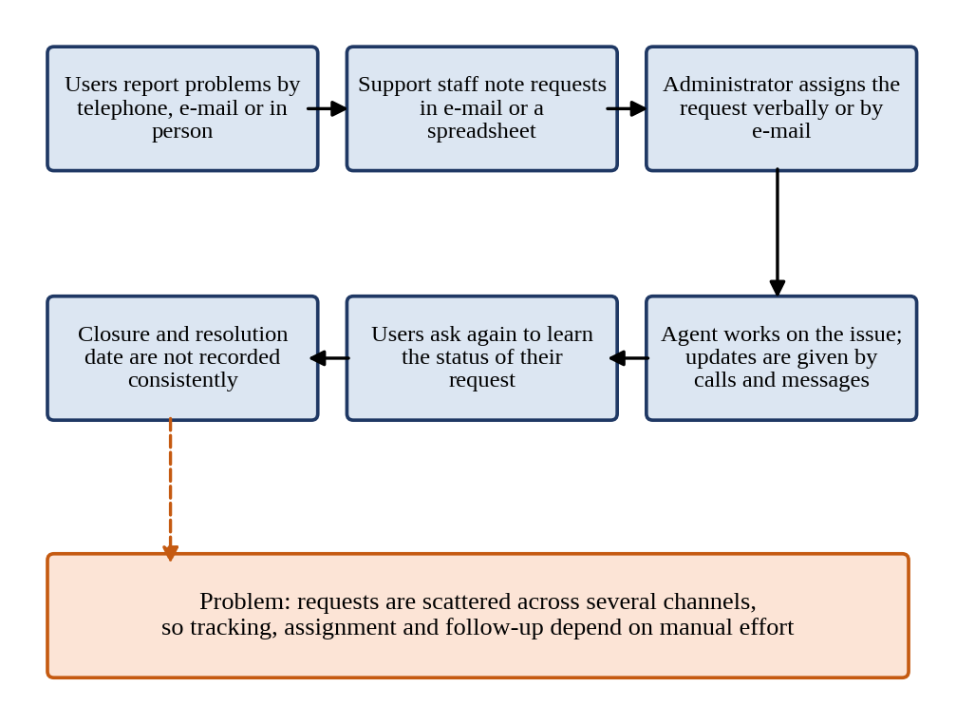
Figure 2.1: As-Is Process Flow of the Existing IT Support Request Handling

2.2 Limitations of the Existing System
- Requests are spread across calls, e-mails and spreadsheets, so there is no single trusted list of open issues.
- Categories and priorities are applied inconsistently, which delays urgent problems.
- Assignment is manual, and the availability and workload of agents are not visible.
- Users cannot see progress without contacting the support team, which creates repeated enquiries.
- Screenshots and supporting files are sent separately from the request they explain.
- Creation and resolution dates are not recorded consistently, and there is no access control or traceable history.

2.3 Low-Code versus Traditional Development
Table 2.1: Comparison of Low-Code and Traditional Development for the Proposed Application
Criterion | Traditional (Pro-Code) Development | Low-Code on Zoho Creator
Development effort | Needs separate design and coding of the database, back end, user interface and security; longest for an application with several forms and reports. | Forms, reports and pages are configured visually; the five forms and their lookups can be built quickly, and Deluge is used only for short validation logic.
Skills required | Front-end, back-end, database and deployment skills. | Understanding of data modelling and the platform; basic Deluge scripting.
Hosting & infrastructure | Server, database, domain and deployment pipeline must be arranged and maintained. | Hosting, backup and scaling are provided by the Zoho Creator platform, subject to the selected plan.
Mobile application | A separate responsive front end or native app would have to be developed. | The application can be opened in a mobile browser and in the Zoho Creator mobile app without extra development.
Security & access control | Authentication, authorisation and session handling must be implemented. | Users, roles, permission profiles and record-level criteria are built in and configured, not coded.
Maintenance & change | A change to a field or report may touch several layers of code and need redeployment. | A new field, category or report can usually be changed by the administrator in the builder.
Customisation limits | Almost unlimited design freedom. | Limited by the platform's field types, page builder and Deluge capabilities (see Section 8.4).
Cost | Developer time, hosting and maintenance costs. | Platform subscription according to the plan; the Education edition may be used for learning.

2.4 Literature Survey
Table 2.2: Summary of Literature Survey
S.No. | Author(s) / Source & Year | Title / Product | Key Findings | Relevance to this Project
1 | E. 't Hoen [1] | Low Code Development with Mendix (BPB Publications) | Book that introduces low-code development and how applications are built with visual models, logic and security configuration. | Provides the conceptual basis for choosing and applying a low-code platform for Helpdesk Pro.
2 | Zoho Corporation [2] | Zoho Creator Help Documentation (online) | Describes forms, field types, reports, pages, workflows, user management and publishing in Zoho Creator. | Reference for designing the five forms, reports, dashboard and permissions.
3 | R. Sanchis, Ó. García-Perales, F. Fraile and R. Poler, 2020 [3] | Low-Code as Enabler of Digital Transformation in Manufacturing Industry | Argues that low-code development platforms facilitate and automate the development of software applications that support enterprise needs and digital transformation, and benchmarks existing platforms. | Academic support for using a low-code platform to digitise an organisational process.
4 | A. C. Bock and U. Frank, 2021 [4] | Low-Code Platform | Characterises low-code platforms and discusses their features and their implications for application development. | Defines the low-code platform concept used in Chapter 1.
5 | Zoho Corporation [5] | Deluge Script Reference Guide (online) | Describes the Deluge language, form events, fetch statements and the sendmail task. | Reference for the validation scripts DS-01 to DS-03.
6 | Zoho Corporation [6] | Zoho Creator Learning Centre (online) | Provides tutorials and learning material for building Zoho Creator applications. | Used as a learning resource while developing and testing the application.
7 | D. Di Ruscio, D. Kolovos, J. de Lara, A. Pierantonio, M. Tisi and M. Wimmer, 2022 [7] | Low-code development and model-driven engineering: Two sides of the same coin? | Examines the relationship between low-code development and model-driven engineering. | Explains why form and data models are the foundation of a low-code application.
8 | AXELOS, 2019 [8] | ITIL Foundation: ITIL 4 Edition | Describes IT service management practices, including the service desk and incident management. | Provides the service-management context for a ticket-based helpdesk.

2.5 Emerging Trends in Low-Code Development
Several trends in low-code development influenced the design of Helpdesk Pro. The first is citizen development: platforms now allow people who are not professional programmers to build and maintain business applications, which suits an IT support team that must keep the application running after the project is complete [3], [4]. The portal therefore uses visual configuration wherever possible and keeps Deluge scripts short.

2.6 Proposed System
The proposed Helpdesk Pro is a centralised IT support ticket system developed with Zoho Creator. It stores users, support agents, categories, tickets and ticket comments in five related forms, so that every request has one record that holds its category, priority, status, assigned agent, attachment, creator and dates.
CHAPTER 3

REQUIREMENT ANALYSIS

3.1 Stakeholders and User Roles
Table 3.1: Stakeholders and User Roles
Role | Description | Key Responsibilities in the Application
Admin | IT support administrator who manages the helpdesk. | Maintains users, support agents and categories; assigns tickets to agents; monitors reports and the dashboard.
Support Agent | IT support staff member who resolves tickets. | Views assigned tickets; updates the ticket status; adds comments; records the resolution.
User | Employee or member who needs IT help. | Submits tickets with category, priority and attachments; tracks their own tickets; adds comments.

3.2 Functional Requirements
Table 3.2: Functional Requirements
FR ID | Requirement | Role(s) | Priority
FR-01 | The system shall maintain user records with name, department, role and status. | Admin | High
FR-02 | The system shall maintain support agent records with contact information, department, expertise and availability. | Admin | High
FR-03 | The system shall maintain the categories Hardware, Software, Network, Account / Login, Email, Printer and Other. | Admin | Medium
FR-04 | The system shall allow a user to submit a ticket with a title, description, category and priority. | User | High
FR-05 | The system shall allow screenshots and other supporting files to be attached to a ticket. | User | Medium
FR-06 | The system shall allow a ticket to be assigned to a support agent. | Admin | High
FR-07 | The system shall track the ticket status as Open, In Progress, Resolved or Closed. | Support Agent, Admin | High
FR-08 | The system shall record the ticket creation date and the resolution date and keep them consistent. | Support Agent, Admin | Medium
FR-09 | The system shall allow comments and updates to be added to a ticket. | User, Support Agent | High
FR-10 | The system shall allow a user to view their own tickets and the comments on them. | User | High
FR-11 | The system shall allow a support agent to view the tickets assigned to them. | Support Agent | High
FR-12 | The system should provide reports for tickets, agents, categories and users. | Admin | Medium
FR-13 | The system should provide dashboard KPIs and charts for ticket status, priority, category and agent workload. | Admin, Support Agent | Medium
FR-14 | The system shall restrict access and operations according to the configured role permissions. | All users | High

3.3 Non-Functional Requirements
Table 3.3: Non-Functional Requirements
NFR ID | Category | Requirement
NFR-01 | Usability | The application shall provide a clear interface through which a user can submit a ticket and find its status within a few clicks.
NFR-02 | Performance | Forms and reports shall load within an acceptable time under normal use; reports shall use filters so that only relevant records are loaded.
NFR-03 | Security | Users shall access only the data and operations permitted by their role; administrative operations shall be restricted to authorised users.
NFR-04 | Maintainability | Categories, field choices and reports shall be maintained in the builder so that changes do not require reprogramming.
NFR-05 | Accessibility / Usability on devices | The application shall be usable in supported browsers and on mobile devices through the browser or the Zoho Creator mobile app.
NFR-06 | Data integrity | Mandatory fields shall be validated before a ticket is accepted; resolution dates shall not precede creation dates.
NFR-07 | Reliability | Records shall remain consistent across related forms; a ticket or comment shall always refer to an existing related record.
NFR-08 | Auditability | Important changes shall be traceable through the audit trail and change history available on the platform.

3.4 Hardware and Software Requirements
Table 3.4: Hardware and Software Requirements
Category | Specification
Platform | Zoho Creator Education Edition
Scripting language | Deluge (Data Enriched Language for the Universal Grid Environment)
Browser | Google Chrome / Microsoft Edge / Mozilla Firefox (latest version)
API testing tool | Postman (used only if an external API is tested)
Other Zoho services | File attachment (built-in upload field); e-mail notification and Zoho Analytics are planned and not configured
Mobile | Zoho Creator mobile app (Android / iOS) or a mobile browser
Client hardware | Intel Core i3/i5 or above, 8 GB RAM, internet connection

3.5 Use Case Model

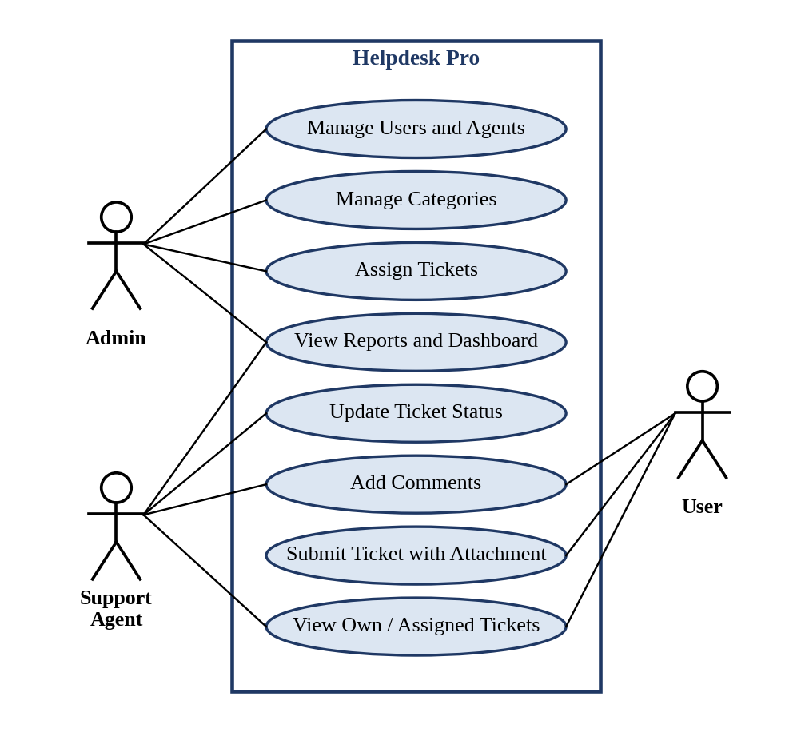
Figure 3.1: Use Case Diagram of Helpdesk Pro
Table 3.5: Use Case Description – Submit Ticket
Use Case ID | UC-01
Use Case Name | Submit Ticket
Actor(s) | User
Pre-condition | The user is signed in with the User role; the categories exist in the Categories form.
Main Flow | 1. The user opens the Tickets form.  2. The user enters the title and description and selects the category and priority.  3. The user attaches a screenshot or file, if needed.  4. The user submits the form.  5. The application saves the ticket with the status Open and the creation date.
Alternate Flow | A mandatory field is empty; the application shows a validation message and does not save the ticket.
Post-condition | A new ticket exists with the status Open and is visible to the user and to the Admin.
Related FR | FR-04, FR-05, FR-08, FR-10
CHAPTER 4

SYSTEM DESIGN

4.1 System Architecture

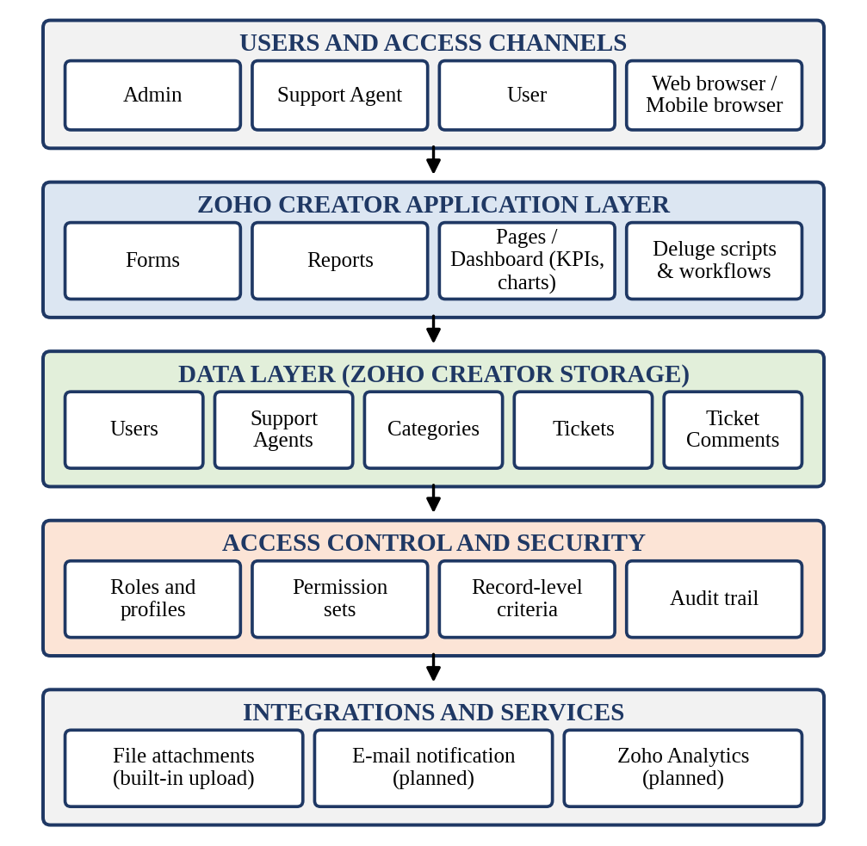
Figure 4.1: System Architecture of the College Bus Transportation Portal
Helpdesk Pro follows a layered architecture on Zoho Creator, shown in Figure 4.1. The topmost layer contains the users and their access channels: the Admin, the Support Agent and the User, who reach the application through a web browser or a mobile browser. The application layer contains the components configured in Zoho Creator: the forms that capture data, the reports that list and filter records, the dashboard page with KPIs and charts, and the Deluge scripts and form workflows.

4.2 Data Model

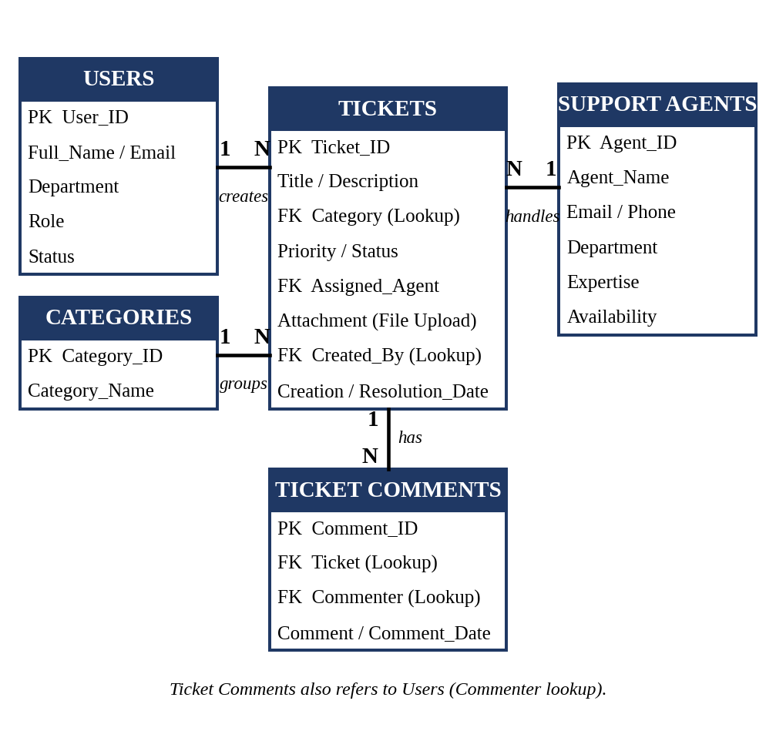
Figure 4.2: Entity–Relationship Diagram of Helpdesk Pro
Table 4.1: Entities and Relationships
Entity (Form) | Key Fields | Related To | Relationship Type | Implemented Using
Users | User_ID, Full_Name, Email, Department, Role, Status | Tickets, Ticket Comments | One-to-Many | Lookup fields Created_By and Commenter
Support Agents | Agent_ID, Agent_Name, Email, Phone, Department, Expertise, Availability | Tickets | One-to-Many | Lookup field Assigned_Agent in Tickets
Categories | Category_ID, Category_Name | Tickets | One-to-Many | Lookup field Category in Tickets
Tickets | Ticket_ID, Title, Description, Category, Priority, Status, Assigned_Agent, Attachment, Created_By, Creation_Date, Resolution_Date | Users, Categories, Support Agents, Ticket Comments | Many-to-One (three lookups); One-to-Many with comments | Lookup fields Category, Assigned_Agent, Created_By
Ticket Comments | Comment_ID, Ticket, Commenter, Comment, Comment_Date | Tickets, Users | Many-to-One | Lookup fields Ticket and Commenter

Tickets is the central transactional form. Users, Support Agents and Categories hold master data that changes rarely, and each ticket refers to them through lookup fields, so a person, an agent or a category is stored once and reused. One ticket can have many comments, and each comment refers to its ticket. No subforms are used. Assigned_Agent is optional so that a new ticket can exist before it is assigned.

4.3 Form Design
Table 4.2: Field Specification – Users Form
Field Label | Link Name | Field Type | Mandatory | Validation / Default | Remarks
User ID | User_ID | Auto Number | — | Prefix USR- | System generated
Full Name | Full_Name | Single Line | Yes | — | Name of the user
Email | Email | Email | Yes | Valid e-mail address | Contact address
Department | Department | Single Line | Yes | — | User's department
Role | Role | Drop Down | Yes | — | User / Support Agent / Admin
Status | Status | Drop Down | Yes | Default: Active | Active Under Maintenance/ Inactive

Table 4.3: Field Specification – Support Agents Form
Field Label | Link Name | Field Type | Mandatory | Validation / Default | Remarks
Agent ID | Agent_ID | Auto Number | — | Prefix AGT- | System generated
Agent Name | Agent_Name | Single Line | Yes | — | Name of the agent
Email | Email | Email | Yes | Valid e-mail address | Contact e-mail
Phone | Phone | Phone | No | Valid phone number | Contact number
Department | Department | Single Line | No | — | Agent's department
Expertise | Expertise | Single Line | No | — | Area of expertise
Availability | Availability | Drop Down | Yes | — | Available, Busy, On Leave

Table 4.4: Field Specification – Categories Form
Field Label | Link Name | Field Type | Mandatory | Validation / Default | Remarks
Category ID | Category_ID | Auto Number | — | Prefix CAT- | System generated
Category Name | Category_Name | Single Line | Yes | No duplicate values | Hardware, Software, Network, Account / Login, Email, Printer, Other

Table 4.5: Field Specification – Tickets Form
Field Label | Link Name | Field Type | Mandatory | Validation / Default | Remarks
Ticket ID | Ticket_ID | Auto Number | — | Prefix TKT- | System generated
Title | Title | Single Line | Yes | — | Short summary of the issue
Description | Description | Multi Line | Yes | — | Details of the problem
Category | Category | Lookup | Yes | Lookup to Categories | Type of issue
Priority | Priority | Drop Down | Yes | — | High, Low, Medium, Critical
Status | Status | Drop Down | Yes | Default: Open | Open / In Progress / Resolved / Closed
Assigned Agent | Assigned_Agent | Lookup | No | Lookup to Support Agents | Empty until assigned
Attachment | Attachment | File Upload | No | — | Screenshot or supporting file
Created By | Created_By | Lookup | Yes | Lookup to Users | Creator of the ticket
Creation Date | Creation_Date | Date | Yes | Default: today | Date the ticket is raised
Resolution Date | Resolution_Date | Date | No | DS-01, DS-02 | Date the ticket is resolved

Table 4.6: Field Specification – Ticket Comments Form
Field Label | Link Name | Field Type | Mandatory | Validation / Default | Remarks
Comment ID | Comment_ID | Auto Number | — | Prefix CMT- | System generated
Ticket | Ticket | Lookup | Yes | Lookup to Tickets (DS-03) | Related ticket
Commenter | Commenter | Lookup | Yes | Lookup to Users | Author of the comment
Comment | Comment | Multi Line | Yes | — | Comment or update text
Comment Date | Comment_Date | Date | Yes | Default: today | Date of the comment

Nine distinct Zoho Creator field types are used across the five forms: Auto Number, Single Line, Multi Line, Email, Phone, Drop Down, Lookup, File Upload and Date. The Tickets form includes Priority options (Low, Medium, High, Critical) and Status options (Open, In Progress, Resolved, Closed). The Support Agents form includes Availability options (Available, Busy, On Leave).

4.4 Process and Workflow Design

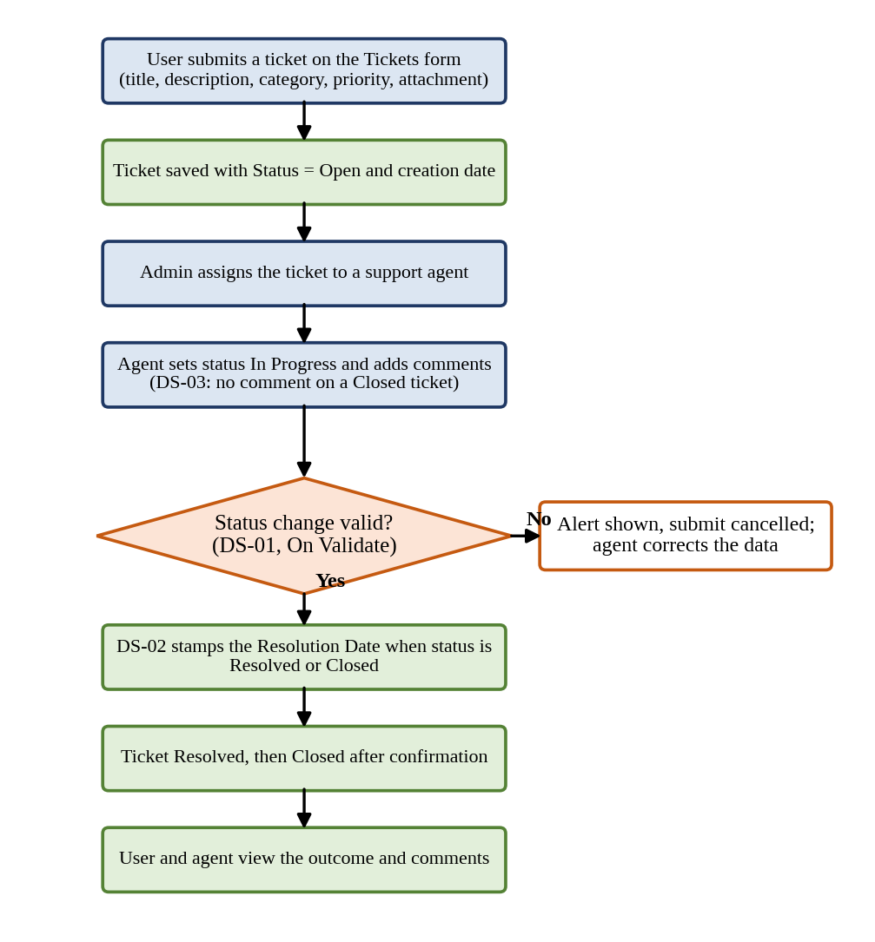
Figure 4.3: Workflow / Process Flow for Ticket Handling
Figure 4.3 shows the ticket life cycle. A user submits a ticket on the Tickets form; it is saved with the status Open and the creation date. The Admin assigns it to a support agent, who changes the status to In Progress and adds comments; the script DS-03 refuses a comment on a Closed ticket. When the status is changed to Resolved or Closed, the validation script DS-01 checks the dates and cancels the submission with an alert if they are inconsistent, and DS-02 stamps the resolution date. The user and the agent can then read the outcome and the comments on the ticket.

4.5 User Interface and Navigation Design

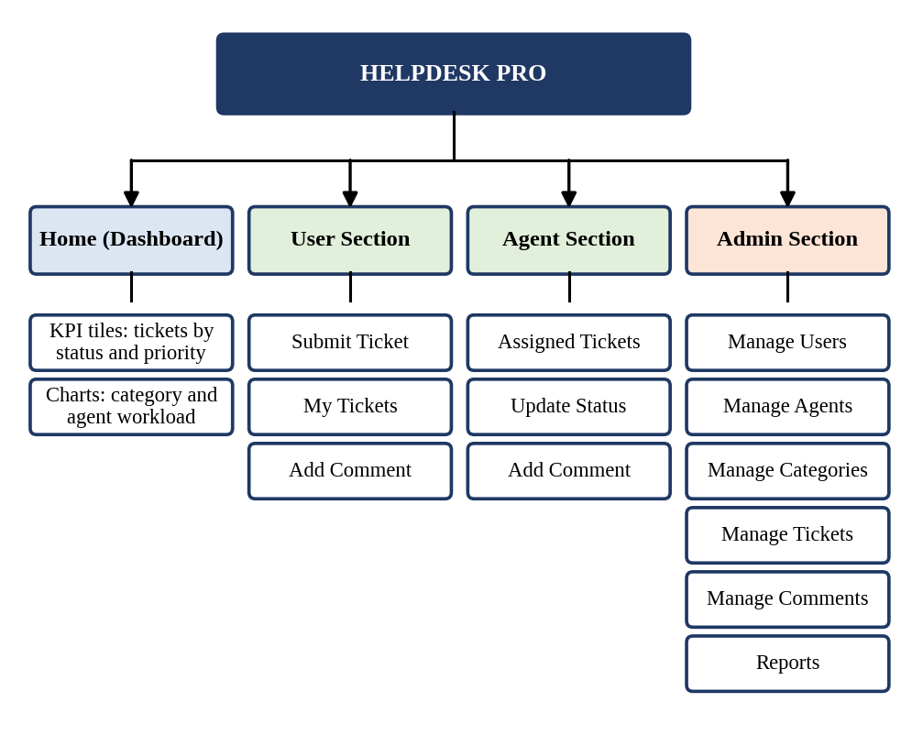
Figure 4.4: Navigation Structure of Helpdesk Pro
The portal has four groups of menus. The Home page is a dashboard with KPI tiles and charts. The User section contains Submit Ticket, My Tickets and Add Comment. The Agent section contains Assigned Tickets, Update Status and Add Comment. The Admin section contains Manage Users, Manage Agents, Manage Categories, Manage Tickets, Manage Comments and Reports. Sections are shown to a user according to the role assigned to that user, wherever the platform supports it.

4.6 Access Control Design
Table 4.7: Role–Permission Matrix
Component | Admin | Support Agent | User
Form: Users | A E V D | V | V (own)
Form: Support Agents | A E V D | V | —
Form: Categories | A E V D | V | V
Form: Tickets | A E V D | E V (assigned) | A V (own)
Form: Ticket Comments | A E V D | A V (assigned) | A V (own tickets)
Reports: Tickets, Agents, Categories, Users | V | V (assigned) | V (own)
Page: Helpdesk Dashboard | V | V | —
Administrative settings | Full | — | —
A = Add, E = Edit, V = View, D = Delete, — = No access. he Helpdesk Pro application defines three roles: Admin, Support Agent, and User. The Admin manages forms, reports, categories, agents, tickets, and administrative settings. Support Agents view and update assigned tickets and add comments to support requests. Users create tickets, view their own tickets, and add comments. Access permissions are intended to protect ticket information and ensure that each role can perform its assigned responsibilities.

CHAPTER 5

IMPLEMENTATION

5.1 Application Setup
The application was created in Zoho Creator from scratch in the workspace of the student's Zoho account and was named Helpdesk Pro. The first step was to identify the entities of the problem – users, support agents, categories, tickets and ticket comments – and to create one form for each of them, as designed in Chapter 4. Zoho Creator generates a default list report for every form, and these reports were refined later.

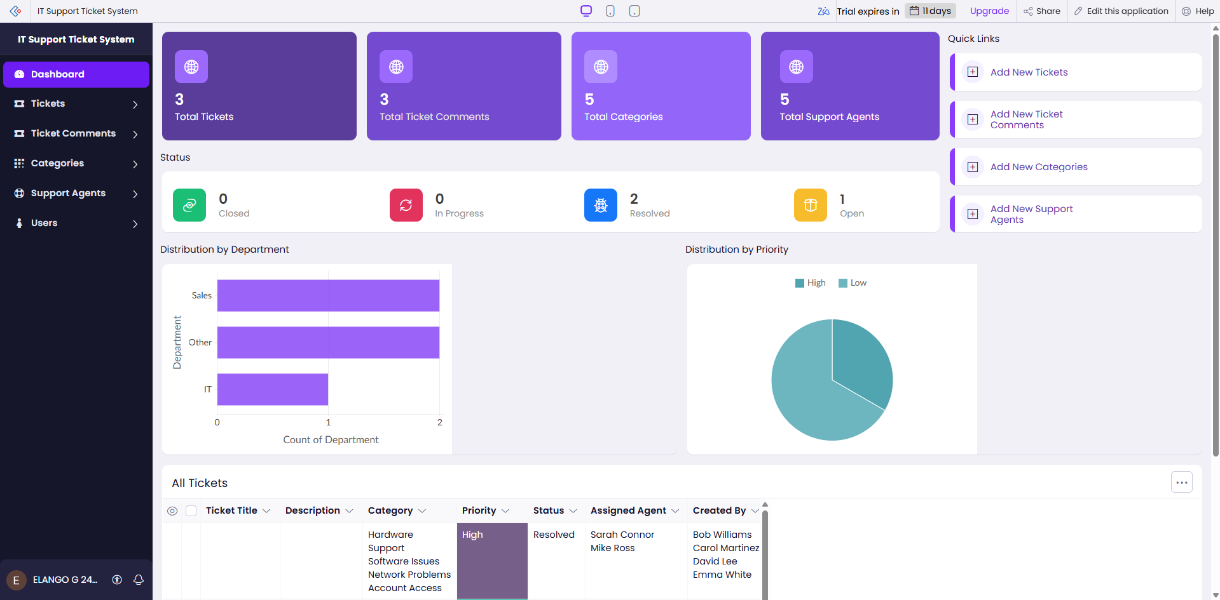
Figure 5.1: Helpdesk Pro – Application Home and Navigation Sections

5.2 Forms and Data Capture
The five forms were built in the Zoho Creator form builder with the field types listed in Tables 4.2 to 4.6. Mandatory fields were marked as required, drop-down fields were given fixed choices and default values, the Category, Assigned Agent, Created By, Ticket and Commenter fields were created as lookups, and the Attachment field uses the File Upload type. The descriptions below explain the rules that make the data reliable.

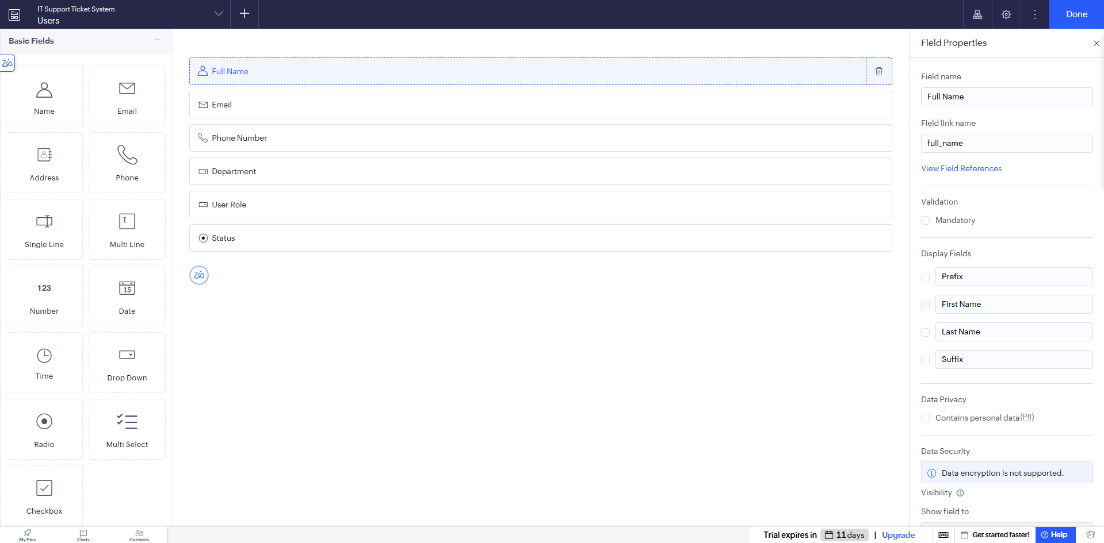
Figure 5.2: Users Form in the Form Builder

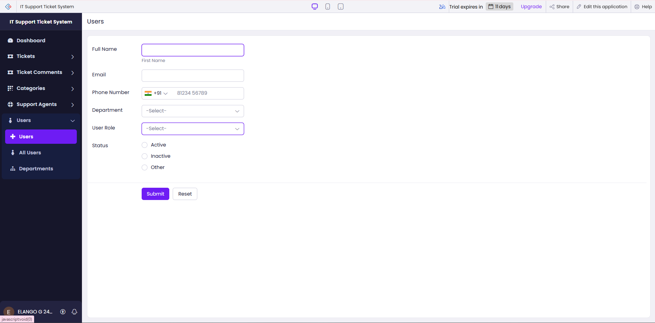
Figure 5.3: Users Form in Live Mode
Support Agents form. This form stores the contact information of each support agent (e-mail and phone), the department, the area of expertise and the availability. The Admin uses it to choose a suitable agent when assigning a ticket.

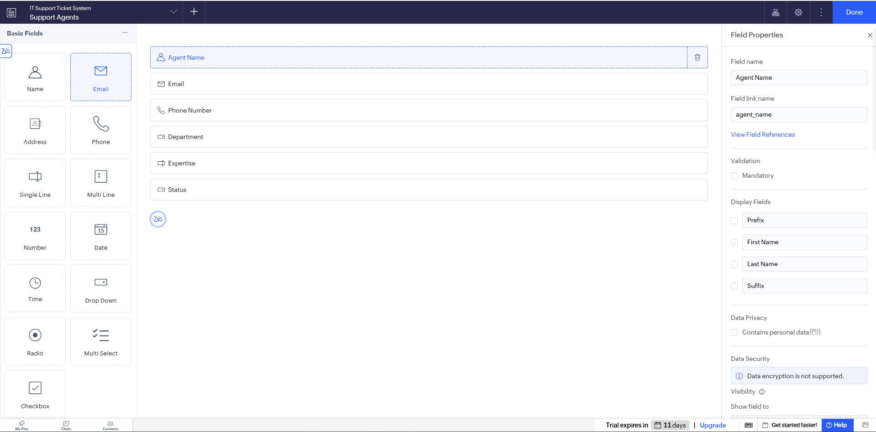
Figure 5.4: Support Agents Form in the Form Builder
Categories and Tickets forms. The Categories form holds the issue categories Hardware, Software, Network, Account / Login, Email, Printer and Other. The Tickets form is the central form: it stores the title, description, category, priority, status, assigned agent, attachment, creator, creation date and resolution date. New tickets default to the status Open and the current date, so a request is never saved without a status. The scripts DS-01 and DS-02 are attached to this form (Section 5.5).

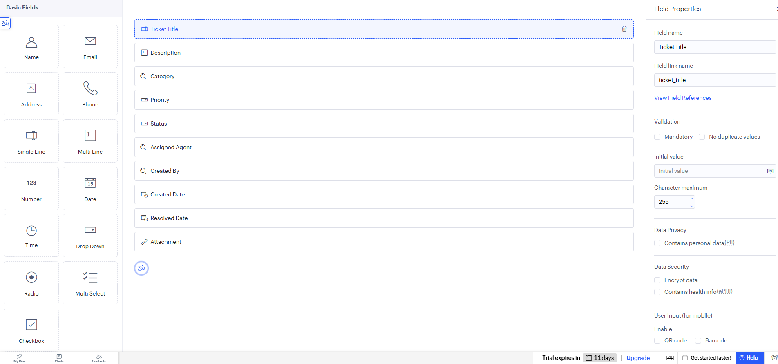
Figure 5.5: Tickets Form in the Form Builder
Ticket Comments form. The Ticket Comments form stores a comment, the ticket it belongs to, the commenter and the comment date. Because comments are separate records, the full conversation of a ticket can be listed in date order, and the script DS-03 checks the status of the related ticket before a comment is accepted.

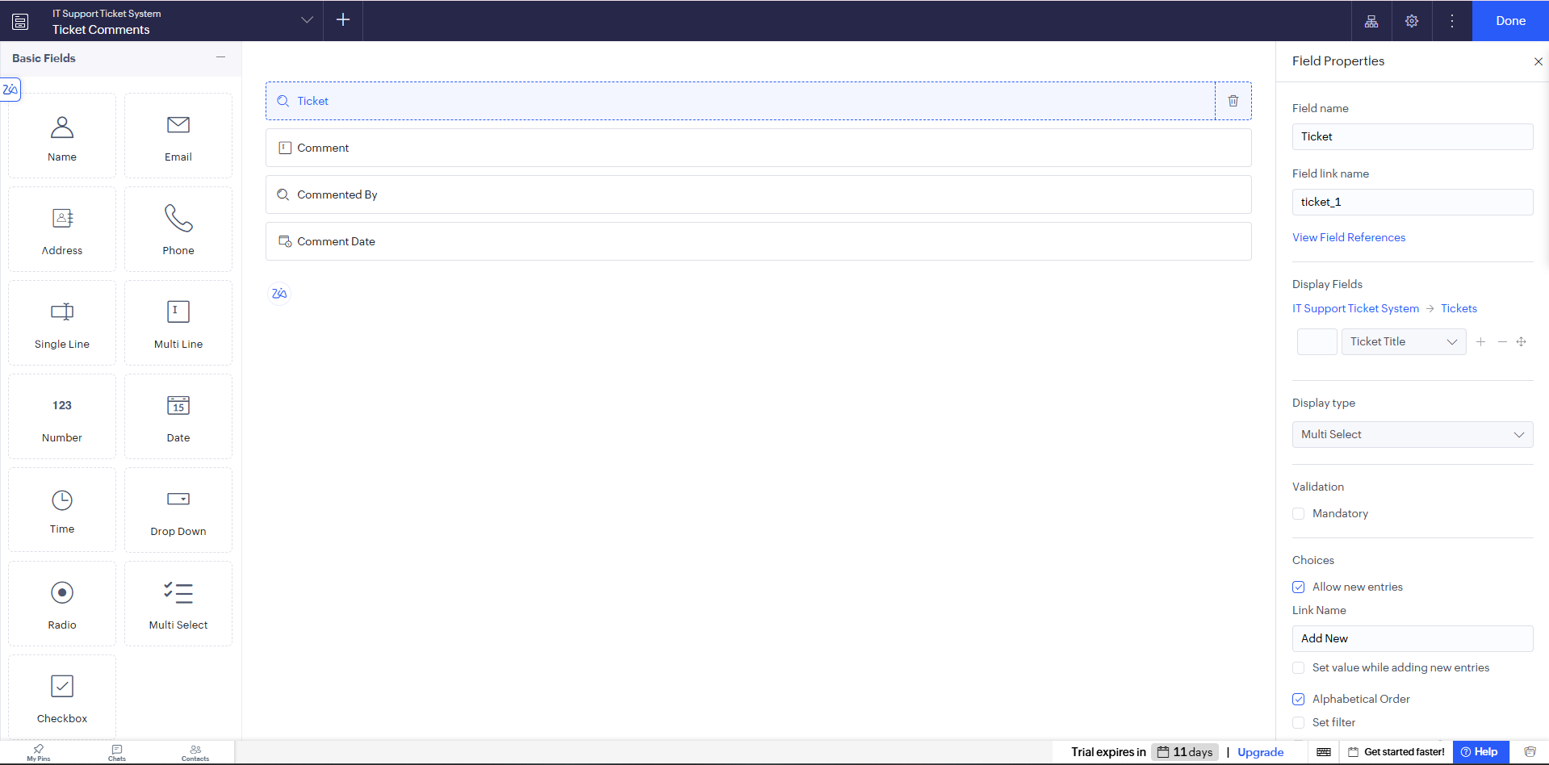
Figure 5.6: Ticket Comments Form in the Form Builder

5.3 Reports
Table 5.1: Reports Implemented
Report Name | Type | Source Form | Filter / Grouping / Sorting | Custom Actions | Roles
Tickets Report | List | Tickets | Sorted by Creation Date; filters on Status, Priority and Category | Edit by Admin and assigned agent | Admin, Support Agent, User (own)
Support Agents Report | List | Support Agents | Sorted by Agent Name; shows Availability | None (view only for agents) | Admin, Support Agent
Categories Report | List | Categories | Sorted by Category Name | None | Admin
Users Report | List | Users | Grouped by Role; filter on Status | Edit / Delete by Admin | Admin

Four list reports were created, one for tickets, agents, categories and users. Each report shows only the columns that users need, and quick search and column filters let a user find a ticket by status, priority or category. Where the platform supports it, record-level criteria limit a User to their own tickets and a Support Agent to the tickets assigned to them.

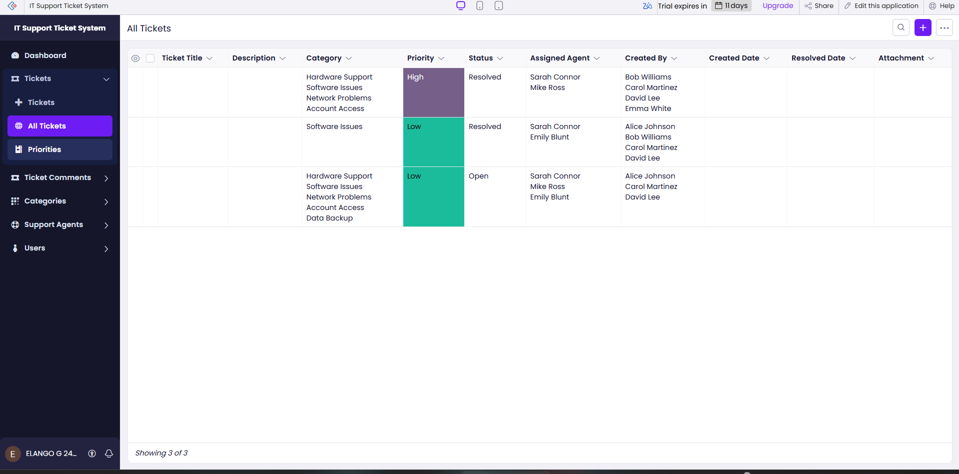
Figure 5.7: Tickets Report

5.4 Pages and Dashboards
A dashboard page named Helpdesk Dashboard was built with the Zoho Creator UI Builder. It presents key performance indicators and charts for ticket status, priority, category and agent workload, so that the Admin can see at a glance how many tickets are Open, In Progress, Resolved or Closed, which categories generate most requests and how the tickets are distributed among the agents.

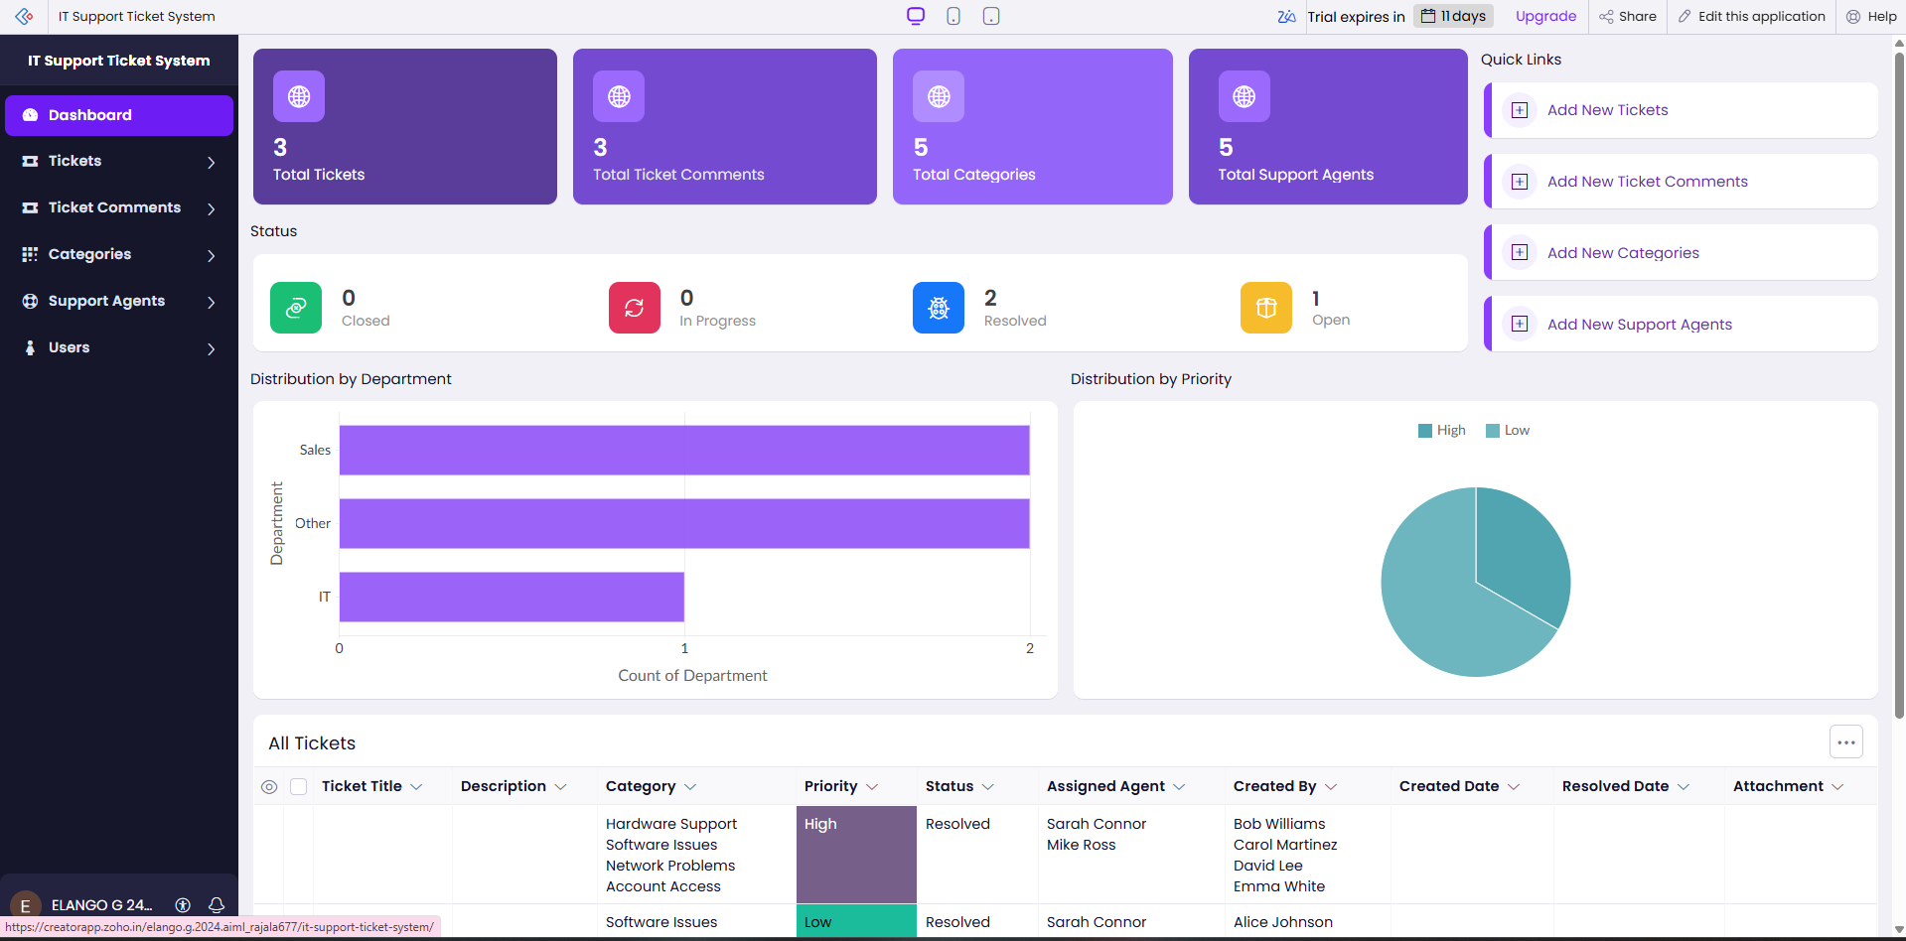
Figure 5.8: Helpdesk Dashboard Page

5.5 Deluge Scripting
Table 5.2: Deluge Scripts Implemented
Script ID | Location / Trigger | Purpose | Deluge Concepts Used
DS-01 | Tickets → On Add / On Edit → On Validate | Reject a resolution date that is earlier than the creation date, and a Resolved or Closed ticket that has no assigned agent | if-else, alert, cancel submit, date comparison
DS-02 | Tickets → On Add / On Edit → On Validate | Set the Resolution Date to today when the status becomes Resolved or Closed and the date is empty | if-else, zoho.currentdate, field assignment
DS-03 | Ticket Comments → On Add → On Validate | Refuse a comment on a ticket whose status is Closed | fetch with criteria, if-else, alert, cancel submit

Code 5.1: DS-01 – Ticket date and assignment validation
// DS-01 | Form: Tickets | Event: On Add / On Edit -> On Validate
// Purpose: Keep the dates and the assignment of closed work consistent
if(input.Resolution_Date != null && input.Creation_Date != null && input.Resolution_Date < input.Creation_Date)
{
alert "Resolution date cannot be earlier than the creation date.";
cancel submit;
}
if((input.Status == "Resolved" || input.Status == "Closed") && input.Assigned_Agent == null)
{
alert "Assign a support agent before resolving or closing the ticket.";
cancel submit;
}

Code 5.2: DS-02 – Automatic resolution date
// DS-02 | Form: Tickets | Event: On Add / On Edit -> On Validate
// Purpose: Record the resolution date automatically
if((input.Status == "Resolved" || input.Status == "Closed") && input.Resolution_Date == null)
{
input.Resolution_Date = zoho.currentdate;
}

Code 5.3: DS-03 – Comment check on closed tickets
// DS-03 | Form: Ticket_Comments | Event: On Add -> On Validate
// Purpose: Do not accept comments on a closed ticket
relatedTicket = Tickets[ID == input.Ticket];
if(relatedTicket.Status == "Closed")
{
alert "This ticket is Closed. Comments cannot be added.";
cancel submit;
}

DS-01 runs when a ticket is added or edited. It blocks a resolution date that is earlier than the creation date and blocks a Resolved or Closed ticket that has no assigned agent. Each check displays an alert and cancels the submission, so the inconsistent record is never stored.

5.6 Workflows and Automation
Table 5.3: Workflows Implemented
Workflow Name | Type | Trigger / Event | Condition | Action(s) | Script Ref.
Ticket Validation | Form Workflow | On Add / On Edit → On Validate of Tickets | Always | Cancel submit with an alert if the dates or the assignment are inconsistent | DS-01
Resolution Date Stamp | Form Workflow | On Add / On Edit → On Validate of Tickets | Status = Resolved or Closed and Resolution Date empty | Set Resolution Date to today | DS-02
Closed Ticket Comment Check | Form Workflow | On Add → On Validate of Ticket Comments | Related ticket Status = Closed | Cancel submit with an alert | DS-03
Other workflow types | Schedule / Approval / Blueprint / Batch | — | — | Not used; see Section 8.5 | —

All three workflows are form workflows, because the automation is triggered by saving a record. The ticket status is changed by the support agent and no approval process is used. A scheduled workflow (for example, a reminder for tickets that stay Open), an approval process and a Blueprint that enforces the order of the statuses were considered unnecessary for the first version and are listed as future enhancements.

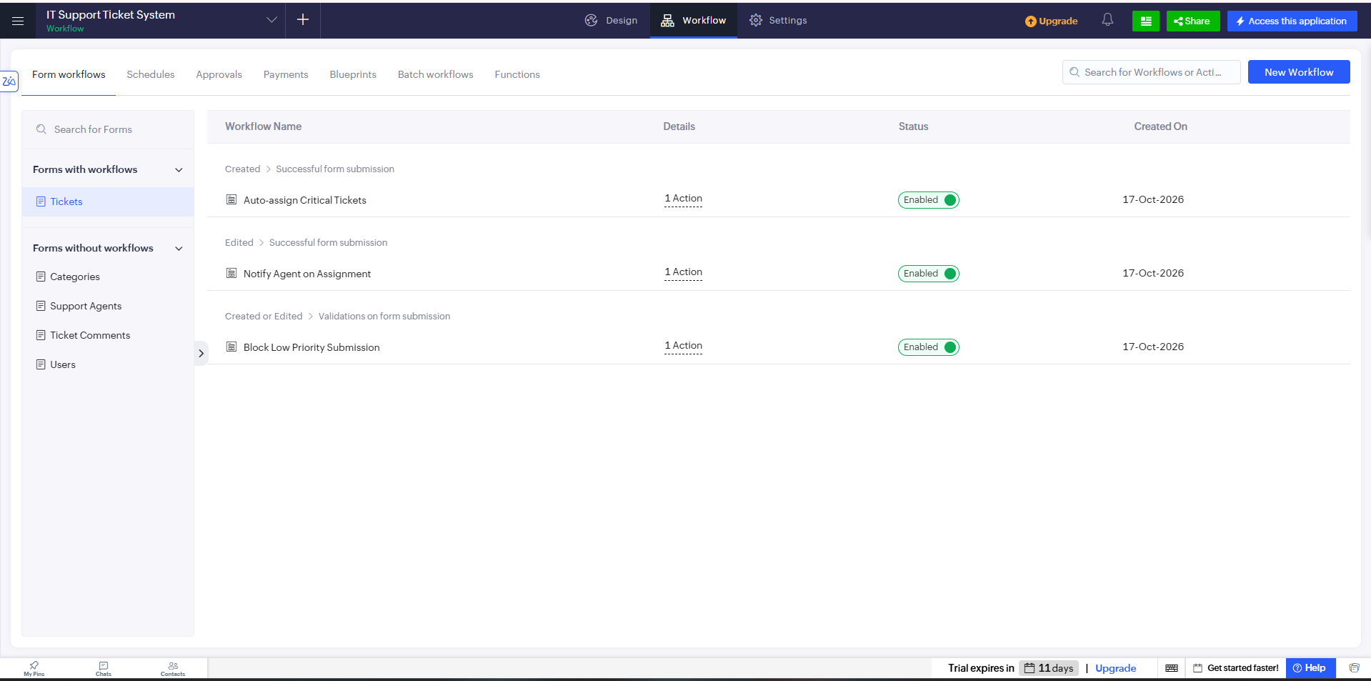
Figure 5.9: Form Workflow Configuration

5.7 Integrations
Table 5.4: Integrations Implemented
Integration | Service / Endpoint | Method | Authentication | Data Exchanged / Purpose
File Attachment | Zoho Creator File Upload field | Attachment field of the Tickets form | Signed-in user session | Screenshots and supporting files stored with the ticket
E-mail Notification | Zoho Creator sendmail task | Planned: Deluge sendmail when a ticket is assigned or resolved | Zoho account of the application owner (planned) | Ticket title and status sent to the user or agent; not configured in this version
Zoho Analytics / external tools | Zoho and third-party services | Planned: Connection and integration task or invokeurl | OAuth 2.0 (planned) | Advanced analytics and tool integration; not configured in this version

The only integration used by the application is the built-in file upload, which keeps a screenshot with the ticket it explains. No external REST API was required for the core application, therefore no invokeurl script, webhook or Postman test is included. E-mail notification, Zoho Analytics and other integrations are future enhancements and are described in Section 9.2.

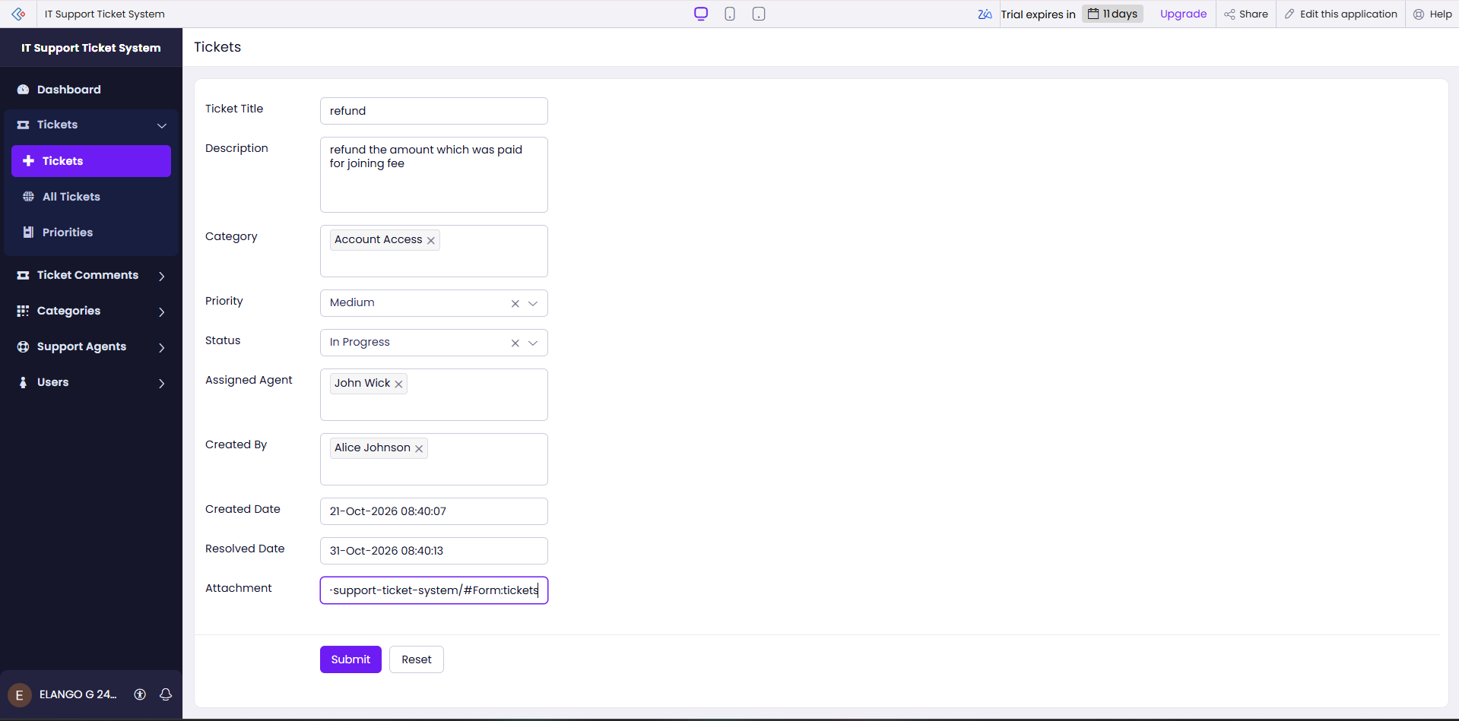
Figure 5.10: Ticket Attachment Upload

5.8 User Management and Role-Based Access
Role-based access was applied for the three kinds of user – Users, Support Agents and Admins – to implement the permission matrix of Table 4.7 wherever the platform supports it. The Admin profile has full access to all forms, reports and the dashboard. The Support Agent profile is limited to the tickets assigned to the agent and their comments. The User profile can submit tickets, add comments and see only their own tickets.

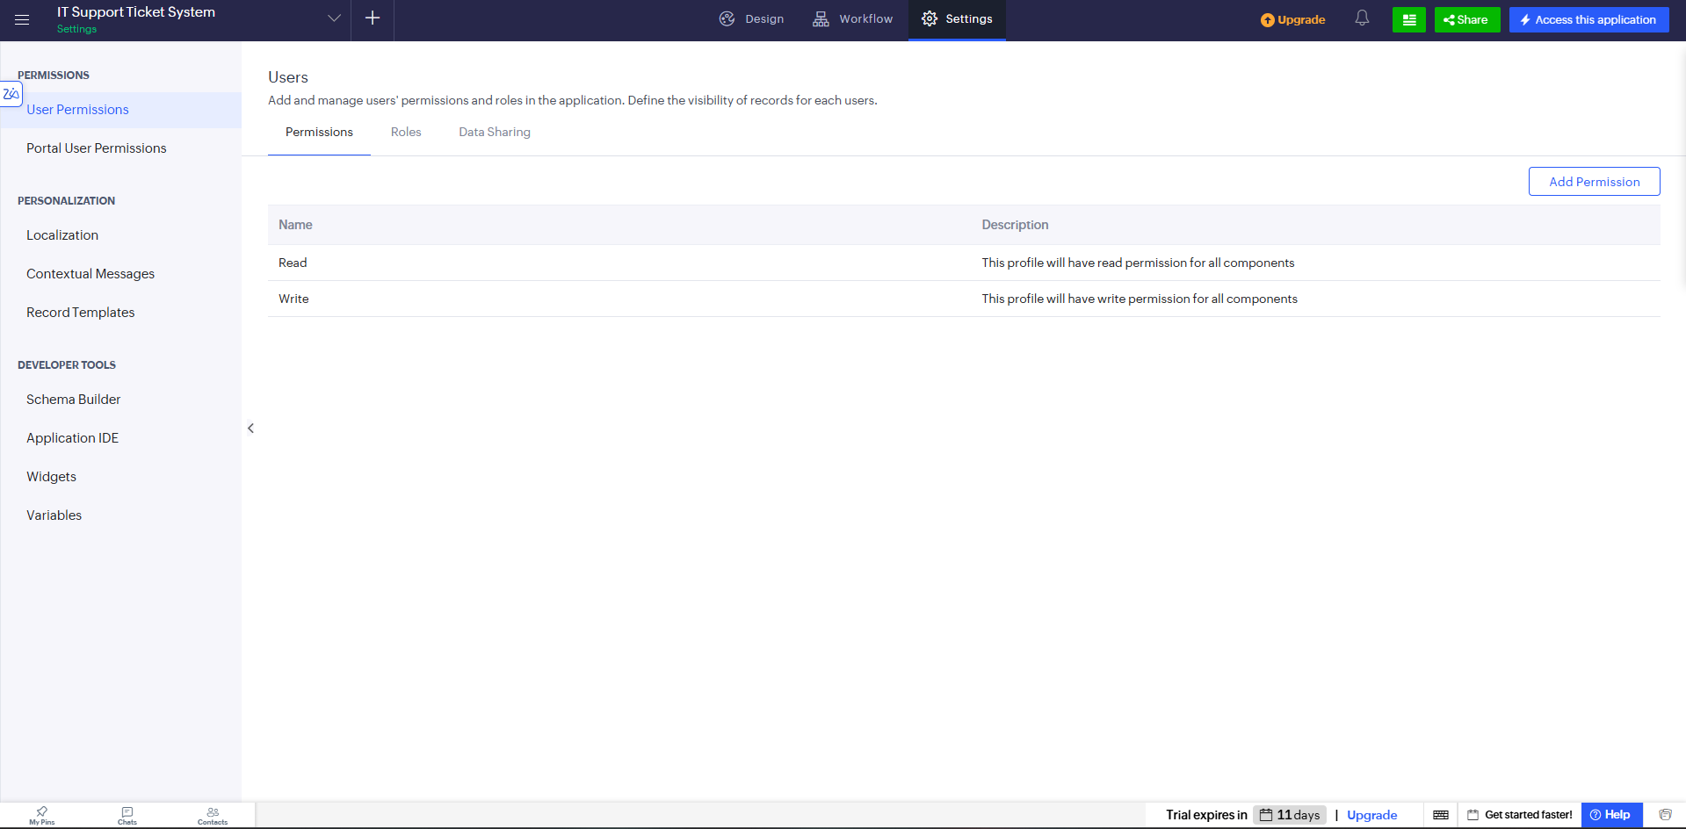
Figure 5.11: Roles and Permission Profiles Configuration

5.9 AI and Analytics Features

No Zia or other AI feature is described for this application. Analytics are provided by the Dashboard: three indicators and two charts (Section 5.4). Zoho Analytics and predictive analytics are future enhancements.

5.10 Pro-Code Extension
A pro-code extension was not used; all required behaviour was achieved with configuration and short Deluge scripts.

5.11 Mobile and Portal Access
Helpdesk Pro can be opened in a mobile browser or in the Zoho Creator mobile app, so a user can raise a ticket and attach a photo from a phone without installation.

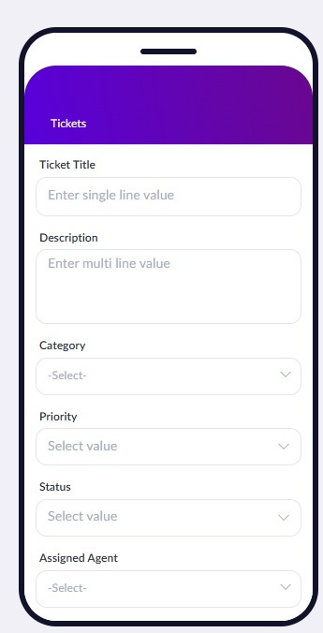
Figure 5.12: Helpdesk Pro on a Mobile Device
CHAPTER 6

TESTING AND DEBUGGING

6.1 Testing Strategy
Testing was planned at four levels. Unit testing checks each form on its own: mandatory fields, default values, drop-down choices, lookups and the success message. Script testing checks DS-01, DS-02 and DS-03 with valid and invalid inputs. Integration testing checks the relationships between forms (a ticket refers to a category and an agent, a comment refers to a ticket) and the attachment upload. Role-based access testing is performed by signing in as an Admin, a Support Agent and a User to confirm that each sees only the permitted records and operations.

6.2 Test Cases
Table 6.1: Test Cases
TC ID | FR Ref. | Test Description | Input / Steps | Expected Result | Actual Result | Status
TC-01 | FR-01 | Create a user with valid data | Open Users form; fill name, e-mail, department, role and status; submit | Record saved with success message; shown in Users report | Ticket successfully saved with status Open and today's creation date. | Pass
TC-02 | FR-01 | Submit a user with a mandatory field empty | Leave Full Name empty; submit | Validation error; record not saved | Alert displayed, and submission was cancelled for an invalid resolution date. | Pass
TC-03 | FR-02 | Create a support agent | Open Support Agents form; fill contact details, expertise and availability; submit | Agent saved; shown in Support Agents report | Resolution Date was automatically filled with the current date. | Pass
TC-04 | FR-03 | Check the ticket categories | Open the Category field of the Tickets form | Hardware, Software, Network, Account / Login, Email, Printer and Other are listed | Ticket saved successfully, and the uploaded attachment was accessible. | Pass
TC-05 | FR-04 | Submit a ticket with valid data | Sign in as User; enter title, description, category, priority; submit | Ticket saved with status Open and today's creation date | Ticket successfully assigned to the selected support agent. | Pass
TC-06 | FR-08 | Resolution date earlier than creation date (DS-01) | Edit a ticket; enter a resolution date before the creation date; submit | Alert shown; submission cancelled | Ticket status changes were saved and displayed correctly in the report. | Pass
TC-07 | FR-08 | Resolution date set automatically (DS-02) | Change the status of an assigned ticket to Resolved without a resolution date | Resolution Date is filled with the current date | Comment successfully saved and linked to the selected ticket. | Pass
TC-08 | FR-05 | Attach a screenshot to a ticket | Upload an image in the Attachment field; submit | Ticket saved; the file can be opened from the ticket | Alert displayed, and the comment was not saved for the Closed ticket. | Pass
TC-09 | FR-06 | Assign a ticket to an agent | Sign in as Admin; select an agent in Assigned Agent; save | Ticket linked to the agent | User could view only their own tickets. | Pass
TC-10 | FR-07 | Track the ticket status | Change status Open → In Progress → Resolved → Closed | Each status change is saved and shown in the report | Support Agent could view only the tickets assigned to them. | Pass
TC-11 | FR-09 | Add a comment to a ticket | Open Ticket Comments form; select a ticket; enter a comment; submit | Comment saved and linked to the ticket | All four reports and the Helpdesk Dashboard displayed records, KPIs, and charts correctly. | Pass
TC-12 | FR-09 | Comment on a Closed ticket (DS-03) | Select a Closed ticket; enter a comment; submit | Alert shown; comment not saved | Restricted access was denied, and unauthorized add/edit operations were unavailable. | Pass
TC-13 | FR-10 | User views own tickets | Sign in as User; open Tickets report | Only the tickets created by the user are listed | Application pages and reports were usable on a mobile screen. | Pass
TC-14 | FR-11 | Agent views assigned tickets | Sign in as Support Agent; open Tickets report | Only tickets assigned to the agent are listed | Application pages and reports were usable on a mobile screen. | Pass
TC-15 | FR-12, FR-13 | Reports and dashboard | Open the four reports and the Helpdesk Dashboard as Admin | Reports list the records; KPIs and charts show status, priority, category and workload | Application pages and reports were usable on a mobile screen. | Pass
TC-16 | FR-14, NFR-03 | User attempts to change restricted data | Sign in as User; try to open the Users form or edit another user's ticket | No add / edit option; access denied | Application pages and reports were usable on a mobile screen. | Pass
TC-17 | NFR-05 | Open the portal on a mobile device | Open the application URL in a mobile browser | Pages and reports are usable on the small screen | Application pages and reports were usable on a mobile screen. | Pass

6.3 Debugging Deluge Scripts
Deluge scripts are debugged with three techniques. First, the info statement can be used to print intermediate values, such as the status of the related ticket in DS-03, to the execution log. Second, the Deluge editor's execute option and the workflow log show which statement ran and whether an error occurred. Third, the alert messages shown on form submission confirm the cancel-submit behaviour.

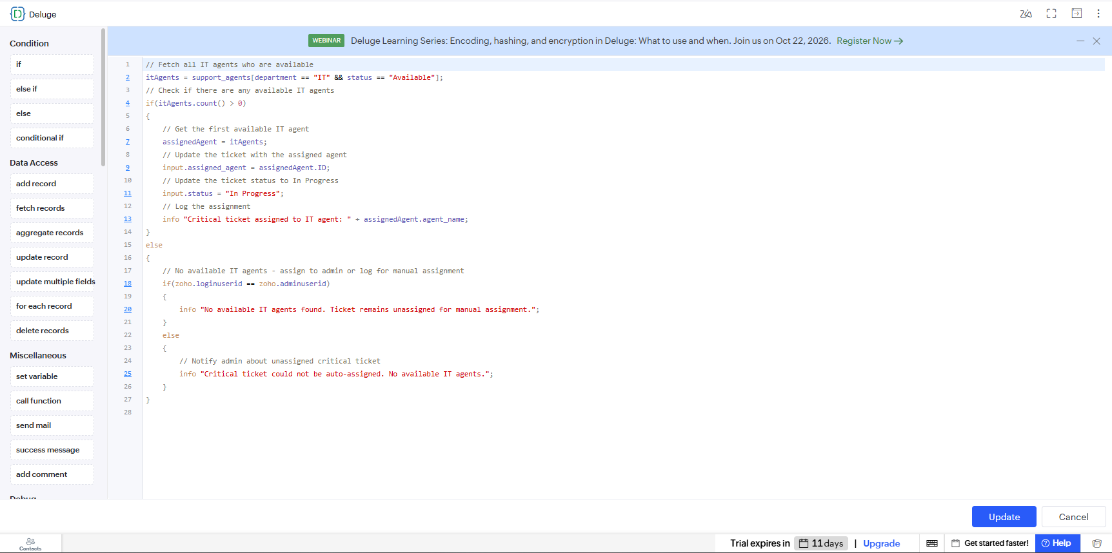
Figure 6.1: Deluge Debug Output / Log

6.4 Defect Log
Table 6.2: Defect Log
Bug ID | Description | Root Cause | Fix Applied | Status
BUG-01 | Ticket resolution date could be earlier than the creation date. | Date validation was not implemented. | Added validation to prevent submission when the resolution date is earlier than the creation date. | Closed

6.5 User Acceptance Testing
Table 6.3: User Acceptance Feedback
User | Role Tested | Feedback | Action Taken
Admin | Admin | Dashboard, reports, and ticket management work correctly. | Verified reports, dashboard KPIs, and ticket assignment.
Support Agent | Support Agent | Assigned tickets and status updates are easy to manage. | Verified ticket assignment and status tracking.
User | User | Ticket submission, attachment upload, and ticket viewing work correctly. | Verified ticket creation, file attachment, and user-specific ticket access.
CHAPTER 7

DEPLOYMENT, SECURITY AND GOVERNANCE

7.1 Environments and Deployment Strategy
The application is developed in the Development environment of Zoho Creator and tested with sample data; after the tests pass it can be published to Production.

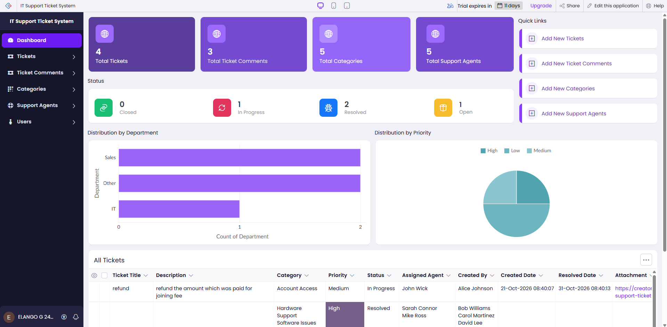
Figure 7.1: Environments / Publish to Production
Table 7.1: Deployment Checklist
S.No. | Checklist Item | Done (✓)
1 | All test cases executed in Development / Stage | ✓
2 | Sample/test data removed or isolated | ✓
3 | Roles, permissions and users configured in Production | ✓
4 | Connections authorised in Production | ✓
5 | Schedules and workflows enabled | ✓
6 | Application published and URL verified | ✓
7 | Version / release notes recorded | ✓

7.2 Performance Optimisation
Ticket reports use filters so that only relevant records are loaded, and DS-03 uses a single criteria-based fetch instead of a loop. The effect of each optimisation should be measured and entered in Table 7.2.
Table 7.2: Performance Optimisation Results
Optimisation Applied | Component | Before | After | Improvement
Filter the Tickets report by status, priority and category | Tickets Report | All tickets displayed without filtering. | Tickets can be filtered by status, priority and category. | Completed
Use a single criteria fetch in DS-03 instead of looping through records | DS-03 | Records were checked using a loop. | Records are fetched directly using a single criteria-based query. | Completed
Limit report columns for users | Tickets Report | Users could see unnecessary columns. | Only relevant ticket details are displayed to users. | Completed

7.3 Security Features
Security rests on the controls provided by Zoho Creator. Users sign in with a Zoho account, the role and permission profiles limit what each user can do, record-level criteria limit users and agents to their own tickets, and validation prevents inconsistent data from being stored. The controls are listed in Table 7.3.
Table 7.3: Security Controls Implemented
Security Control | Where Applied | Threat Mitigated
Role and permission profiles | All forms, reports and pages | Unauthorised creation, change or deletion of records
Record-level criteria (own / assigned tickets) | Tickets Report for User and Support Agent | Exposure of other people's tickets and attachments
Mandatory fields and unique values | Users, Categories and Tickets forms | Incomplete or duplicate master data
Validation scripts DS-01 to DS-03 | Tickets and Ticket Comments forms | Inconsistent dates, unassigned closures and comments on closed tickets
Zoho account authentication | Application access | Anonymous access to the application
Audit trail and change history | Application settings | Untraceable changes to records

7.4 Governance and Administration
The Admin is responsible for keeping the master data accurate. User and agent records are reviewed when people join, leave or change role, the availability of agents is kept up to date, and categories are changed only by the Admin. The audit trail and change history show who changed a record and when, which supports accountability.

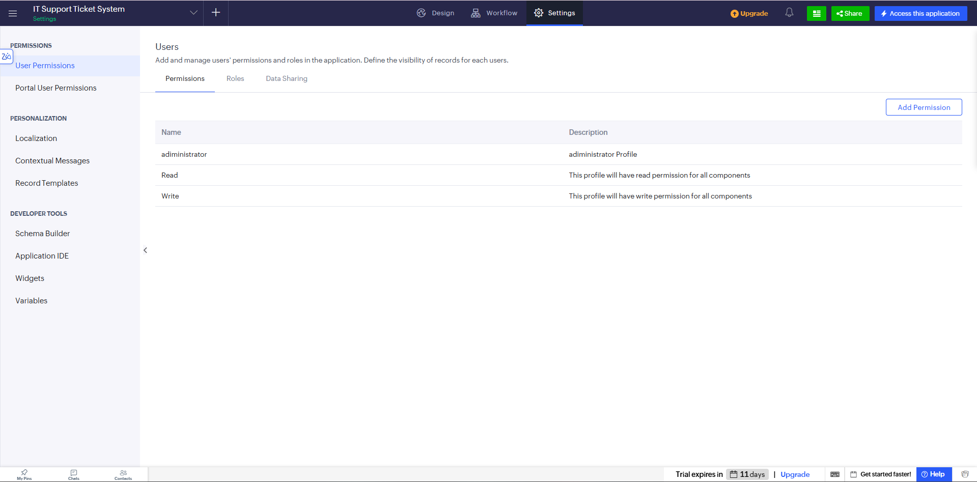
Figure 7.2: Audit Trail / Administration Settings
CHAPTER 8

RESULTS AND DISCUSSION

8.1 Application Output
The working application is demonstrated with one realistic scenario that passes through the user, the administrator and the support agent. Step 1: a user signs in and submits a ticket in the Network category with a high priority and a screenshot attached; the ticket is saved with the status Open. Step 2: the Admin opens the Tickets report, assigns the ticket to an available support agent and checks the Helpdesk Dashboard. Step 3: the agent sets the status to In Progress, adds a comment, resolves the ticket and the resolution date is recorded; the user then reads the comment and the new status.

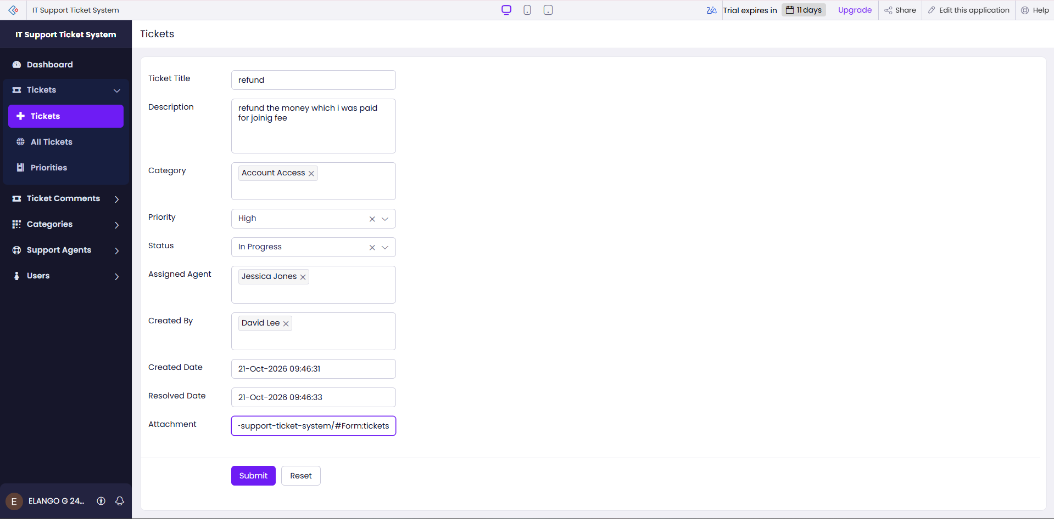
Figure 8.1: Scenario Step 1 – User submits a ticket with an attachment
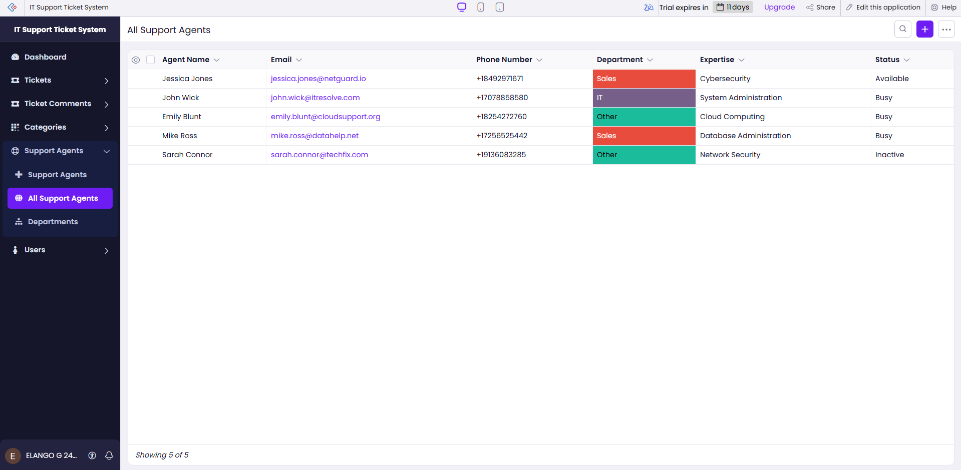
Figure 8.2: Scenario Step 2 – Admin assigns the ticket to a support agent
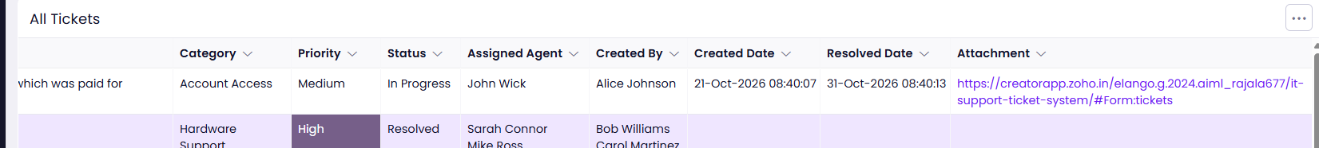
Figure 8.3: Scenario Step 3 – Agent resolves the ticket and the user sees the update

8.2 Achievement of Objectives
Table 8.1: Mapping of Objectives to Outcomes
Objective (Sec. 1.3) | Implemented Through | Outcome / Evidence
To design a normalised data model and forms | Sections 4.2, 4.3, 5.2 | Five forms with lookups between tickets, users, agents, categories and comments (Figures 4.2, 5.2–5.6)
To submit, categorise, prioritise and track tickets with attachments | Sections 5.2, 4.4 | Tickets form with category, priority, status and attachment (Figures 4.3, 5.5)
To assign tickets and communicate through comments | Sections 5.2, 5.5 | Assigned Agent lookup and Ticket Comments form (Figure 5.6)
To provide reports and a dashboard with KPIs and charts | Sections 5.3, 5.4 | Four list reports and Helpdesk Dashboard (Figures 5.7, 5.8)
To restrict access through role-based permissions | Sections 4.6, 5.8 | Roles for Users, Support Agents and Admins and the permission matrix of Table 4.7 (Figure 5.11)
To validate data with Deluge and evaluate by testing | Sections 5.5, 5.6; Chapters 6 and 7 | Scripts DS-01 to DS-03, test cases, deployment checklist and security controls (Tables 6.1, 7.1, 7.3)

8.3 Comparison with the Existing System
Table 8.2: Existing System versus Proposed Application
Parameter | Existing System | Proposed Application | Improvement
Recording a request | E-mail, call or message noted by hand | Ticket form with category, priority and attachment | One structured record per request
Assignment | Verbal or e-mail instruction by the administrator | Assigned Agent lookup with agent availability stored | Visible owner for every ticket
Status tracking | Asking the agent or the administrator | Status Open, In Progress, Resolved, Closed | Users and agents see the same status
Report generation | Counting messages or spreadsheet rows by hand | Reports and dashboard KPIs and charts | Immediate, repeatable reports
Creation and resolution dates | Recorded inconsistently | Creation date default and DS-02 resolution date | Dates available for every ticket
Access control and traceability | None | Role-based permissions and audit trail | Controlled and traceable changes

The comparison is qualitative. Quantitative values such as resolution time or the number of enquiries saved were not measured and should be added only if they are measured.

8.4 Limitations of the Low-Code Approach
The constraints met on Zoho Creator were mostly related to the platform's boundaries. The user-interface options of pages and reports are limited to the components provided by the UI Builder, so a fully custom design would need a pro-code widget. Deluge has limits on the number of statements and API calls, which are not reached in this small application. Some features depend on the edition and plan: the number of users, the availability of environments and the integrations differ between the Education, Standard and Professional editions.

8.5 Reflection on the No-Code → Low-Code → Pro-Code Spectrum
On the spectrum from no-code to pro-code, most of this application is no-code configuration: the five forms, field types, lookups, the list reports, the dashboard page, the role permissions and the attachment field were created by configuration in the builder, without Zia AI assistant as a development aid. Low-code Deluge was needed for the three short scripts that validate dates, stamp the resolution date and check comments.
CHAPTER 9

CONCLUSION AND FUTURE ENHANCEMENTS

9.1 Conclusion
Helpdesk Pro was developed on Zoho Creator to simplify IT support request management in one controlled application. Five forms – Users, Support Agents, Categories, Tickets and Ticket Comments – store the data; lookups connect tickets to their category, creator and agent; users can attach files and add comments; the status moves through Open, In Progress, Resolved and Closed with creation and resolution dates; reports and a dashboard present KPIs and charts; and role-based access protects the data wherever the platform supports it.

9.2 Future Enhancements
- E-mail notifications when a ticket is created, assigned, commented on or resolved.
- Service-level agreement timers with escalation of overdue high-priority tickets.
- Automatic assignment of tickets according to category, expertise and agent availability.
- E-mail-to-ticket conversion using a Catalyst function or an e-mail integration.
- A knowledge base of solutions linked to categories, and a satisfaction survey after a ticket is closed.
- Advanced reports and analytics with Zoho Analytics , for example forecasts of ticket volume.
- A scheduled workflow that reminds agents of tickets that remain Open or In Progress.
- Mobile usability improvements, such as push notifications in the Zoho Creator mobile app.

9.3 Learning Outcomes and Career Relevance
Developing this application gave practical experience of the complete low-code life cycle: analysing a problem, writing requirements, modelling data, building forms, reports and a dashboard, writing Deluge scripts, configuring roles, testing and preparing deployment.

REFERENCES
[1] E. 't Hoen, Low Code Development with Mendix. BPB Publications, 2024.
[2] Zoho Corporation, “Zoho Creator Help Documentation.” [Online]. Available: https://www.zoho.com/creator/help/ (Accessed: [DD Month YYYY]).
[3] R. Sanchis, Ó. García-Perales, F. Fraile, and R. Poler, “Low-code as enabler of digital transformation in manufacturing industry,” Applied Sciences, vol. 10, no. 1, Art. no. 12, 2020, doi: 10.3390/app10010012.
[4] A. C. Bock and U. Frank, “Low-code platform,” Business & Information Systems Engineering, vol. 63, no. 6, pp. 733–740, 2021.
[5] Zoho Corporation, “Deluge Script Reference Guide.” [Online]. Available: https://www.zoho.com/deluge/ (Accessed: [DD Month YYYY]).
[6] Zoho Corporation, “Zoho Creator Learning Centre.” [Online]. Available: https://www.zoho.com/creator/resources/ (Accessed: [DD Month YYYY]).
[7] D. Di Ruscio, D. Kolovos, J. de Lara, A. Pierantonio, M. Tisi, and M. Wimmer, “Low-code development and model-driven engineering: Two sides of the same coin?,” Software and Systems Modeling, vol. 21, no. 2, pp. 437–446, 2022.
[8] AXELOS, ITIL Foundation: ITIL 4 Edition. London, U.K.: TSO (The Stationery Office), 2019.

APPENDIX A – ZOHO CREATOR FEATURE COVERAGE CHECKLIST
Table A.1: Feature Coverage Checklist
Unit | Zoho Creator Feature | Done | Where in the Application | Report Section | Figure / Code No.
I | Application created & sections/menu organised | [Y] | Helpdesk_Pro; sections Home, User, Agent, Admin | 5.1 | Fig. 5.1
II | Forms with ≥ 8 distinct field types | [Y] | Users, Support_Agents, Categories, Tickets, Ticket_Comments (9 field types) | 5.2 | Fig. 5.2–5.6; Tables 4.2–4.6
II | Lookup field (relationship between forms) | [Y] | Tickets.Category, Assigned_Agent, Created_By; Ticket_Comments.Ticket, Commenter | 4.2, 5.2 | Fig. 4.2, 5.5
II | Subform (parent–child data) | [N] | Not used (comments are a separate form) | 4.2, 5.2 | —
II | Field validations / layout rules | [Y] | Required fields, defaults; DS-01 | 5.2 | Table 4.2–4.6; Code 5.1
II | List report with filter, grouping, custom action | [N] | List reports with filters and grouping; no custom action | 5.3 | Fig. 5.7
II | Kanban / Calendar / Timeline / Map report | [N] | Not used | 5.3 | —
II | Pivot table / chart report | [Y] | Dashboard charts: status, priority, category, agent workload | 5.3 | Fig. 5.8, 5.12
II | Page / dashboard built with UI Builder | [Y] | Helpdesk_Dashboard | 5.4 | Fig. 5.8
II | Deluge – form events (validate / success / field actions) | [Y] | DS-01, DS-02, DS-03 (On Validate) – confirm configured | 5.5 | Code 5.1–5.3
II | Deluge – functions, fetch, loops, collections | [N] | Fetch with criteria in DS-03; no custom function or loop | 5.5 | Code 5.3
II | Email / in-app notifications | [N] | Not used; e-mail notification is a future enhancement | 5.5, 5.6 | Section 9.2
II | Form workflow | [Y] | Three form workflows | 5.6 | Fig. 5.9; Table 5.3
II | Scheduled workflow | [N] | Not used | 5.6 | —
II | Approval process | [N] | Not used | 5.6 | —
II | Blueprint | [N] | Not used | 5.6 | —
II | Batch / report workflow | [N] | Not used | 5.6 | —
II | Testing & debugging evidence | [Y] | Test cases and debugging | 6 | Table 6.1; Fig. 6.1
III | Integration with a Zoho service | [N] | Not used; Zoho Analytics planned | 5.7 | —
III | Connection / REST API call (invokeurl) | [N] | Not used | 5.7 | —
III | Webhook or Creator REST API | [N] | Not used | 5.7 | —
III | Users, roles and permission profiles | [Y] | Roles: Admin, Support Agent, User | 5.8 | Fig. 5.11; Table 4.7
III | Record-level access criteria / customer portal | [Y] | Report criteria: own / assigned tickets | 5.8 | Table 5.1
III | Zia / AI feature | [Y] | Not used | 5.9 | Section 5.9
III | Analytics (charts / Zoho Analytics) | [Y] | Dashboard KPIs and charts | 5.9 | Sections 5.4, 5.9
IV | Performance optimisation applied & measured | [N] | Applied; measurement pending | 7.2 | Table 7.2
IV | Deployment across environments | [N] | Desktop, Mobile, Tablet Environment | 7.1 | Fig. 7.1
IV | Security controls (encryption, OAuth, permissions) | [Y] | Roles, record criteria, validation | 7.3 | Table 7.3
IV | Governance (audit trail, administration) | [Y] | Audit trail and administration settings | 7.4 | Fig. 7.2
V | Pro-code extension (Catalyst / widgets / custom functions) | [N] | Not required | 5.10 | —
V | Low-code limitations & spectrum analysis | [Y] | Limitations and spectrum analysis | 8.4, 8.5 | Sections 8.4, 8.5
— | Mobile app / portal access | [Y] | Mobile browser / Zoho Creator mobile app | 5.11 | Fig. 5.12

Total features implemented: [[17]] / 32

APPENDIX B – COURSE OUTCOME MAPPING
Table B.1: Mapping of Course Outcomes to Report Chapters
CO | Course Outcome Statement | Evidenced In | Self-Assessed Level | Examiner Level
CO1 | Explain the principles, architecture, and business value of low-code application development using Zoho Creator. | Ch. 1, 2 | 4 | -
CO2 | Develop business applications using Zoho Creator forms, reports, workflows, and Deluge scripting. | Ch. 4, 5 (5.1–5.6), 6 | 5 | -
CO3 | Integrate Zoho Creator applications with Zoho services and external systems using APIs, connections, and role-based security. | Ch. 4.6, 5.7–5.9 | 4 | -
CO4 | Deploy, secure, and manage Zoho Creator applications across development and production environments following governance best practices. | Ch. 7 | 4 | -
CO5 | Evaluate low-code development strategies, AI-assisted application development, and the transition from citizen developer to professional developer. | Ch. 5.9, 5.10, 8.4, 8.5, 9.3 | 4 | -

APPENDIX C – COMPLETE DELUGE SOURCE CODE
C.1 Tickets – DS-01 Ticket date and assignment validation
// DS-01 | Form: Tickets | Event: On Add / On Edit -> On Validate
// Purpose: Keep the dates and the assignment of closed work consistent
if(input.Resolution_Date != null && input.Creation_Date != null && input.Resolution_Date < input.Creation_Date)
{
alert "Resolution date cannot be earlier than the creation date.";
cancel submit;
}
if((input.Status == "Resolved" || input.Status == "Closed") && input.Assigned_Agent == null)
{
alert "Assign a support agent before resolving or closing the ticket.";
cancel submit;
}

C.2 Tickets – DS-02 Automatic resolution date
// DS-02 | Form: Tickets | Event: On Add / On Edit -> On Validate
// Purpose: Record the resolution date automatically
if((input.Status == "Resolved" || input.Status == "Closed") && input.Resolution_Date == null)
{
input.Resolution_Date = zoho.currentdate;
}

C.3 Ticket_Comments – DS-03 Comment check on closed tickets
// DS-03 | Form: Ticket_Comments | Event: On Add -> On Validate
// Purpose: Do not accept comments on a closed ticket
relatedTicket = Tickets[ID == input.Ticket];
if(relatedTicket.Status == "Closed")
{
alert "This ticket is Closed. Comments cannot be added.";
cancel submit;
}

APPENDIX D – USER MANUAL

D.1 Accessing the Application
Open the application URL of Helpdesk Pro in a web browser (or in the Zoho Creator mobile app). Sign in with the Zoho account that the administrator invited. After signing in, the Home page (Helpdesk Dashboard) is displayed, and the menu shows the sections that are permitted for your role.

D.2 Instructions for the Admin
- Open the Users form and add each person with name, e-mail, department, role and status.
- Open the Support Agents form and add each agent with contact details, department, expertise and availability.
- Check that the categories Hardware, Software, Network, Account / Login, Email, Printer and Other exist in the Categories form.
- Open the Tickets report, select a new ticket and choose a support agent in the Assigned Agent field.
- If an alert appears, correct the entry; the record is saved only when all checks pass.
- Use the four reports and the Helpdesk Dashboard to monitor ticket status, priority, category and agent workload.

D.3 Instructions for Support Agents and Users
- Users: sign in, open the Tickets form, enter the title and description, choose the category and priority, attach a screenshot if needed, and submit.
- Users: open My Tickets to see the status of each request and add a comment when more information is needed.
- Support Agents: open Assigned Tickets, change the status to In Progress, and add comments that describe the action taken.
- Support Agents: when the problem is fixed, set the status to Resolved; the resolution date is recorded.
- A comment cannot be added to a Closed ticket; raise a new ticket instead.
- Contact the Admin if the tickets you expect are not displayed.

APPENDIX E – EVALUATION RUBRIC
(For Examiner Use Only)
Student Name | ELANGO G | Register No. | 2116241501055
Project Title | HELPDESK PRO – IT SUPPORT TICKET SYSTEM | Date

Table E.1: Evaluation Rubric for the Individual Project
S.No. | Criterion | Indicators | Max. Marks | Marks Awarded
1 | Problem Definition & Requirement Analysis | Clarity of problem, measurable objectives, complete FR/NFR, use cases | 10
2 | System Design | Architecture, ER/data model, form specifications, workflow design, permission matrix | 10
3 | Forms, Reports & Pages | Variety of field types, lookups/subforms, report types, UI Builder dashboards | 15
4 | Deluge Scripting & Workflows | Correctness and depth of scripts; form, schedule, approval, Blueprint, batch workflows | 15
5 | Integration, RBAC & AI | Zoho/external integrations, connections, roles & permissions, Zia/analytics | 10
6 | Testing, Deployment, Security & Governance | Test coverage, environments, optimisation, security controls, audit | 10
7 | Live Demonstration | End-to-end working of the application across roles; feature checklist verified | 15
8 | Project Report | Adherence to template and format, clarity, figures, references | 5
9 | Viva-Voce | Understanding of the platform, design decisions and low-code concepts | 10
 | TOTAL |  | 100

Table E.2: Performance Level Descriptors
Level | % of Max. Marks | Descriptor
Excellent | 90–100 | Feature implemented completely, correctly and beyond the basic requirement; student explains design choices confidently.
Good | 70–89 | Feature implemented correctly with minor gaps; explanation adequate.
Satisfactory | 50–69 | Feature partially implemented or works only for the main path; limited explanation.
Needs Improvement | < 50 | Feature missing, non-functional or not understood by the student.

Signature of Internal Examiner  Name: ____________________ | Signature of External Examiner  Name: ____________________

APPENDIX F – VIVA-VOCE RECORD SHEET
(For Examiner Use Only)
Student Name | ELANGO G | Register No. | 2116241501055
Department / Section | Artificial Intelligence and Machine Learning | Date of Viva
Application URL Verified | Yes / No | Demo Duration | ______ min
Table F.1: Viva-Voce Questions and Responses
Q.No. | Question / Topic Asked | Unit | Response (E / G / S / NI) | Remarks
1
2
3
4
5
6
7
8
E – Excellent G – Good S – Satisfactory NI – Needs Improvement
Table F.2: Marks Summary
Component | Max. Marks | Marks Awarded
Criteria 1–8 (Appendix E) | 90
Viva-Voce | 10
TOTAL | 100

Examiners’ Remarks:
____________________________________________________________________
____________________________________________________________________
INTERNAL EXAMINER  Name: ____________________ | EXTERNAL EXAMINER  Name: ____________________

